# **DELHI TECHNOLOGICAL UNIVERSITY**

**DIGITAL ELECTRONICS LAB FILE**

**(EC - 262)**



**SUBMITTED BY: SUBMITTED TO:**

Ritik Singh Mr. Sachin Taran

2K19/CO/319

**DELHI TECHNOLOGICAL UNIVERSITY**

**(Formerly Delhi College of Engineering)**

**Bawana Road, Delhi – 110042**

**Index**

|  |  |  |  |
| --- | --- | --- | --- |
| **S.N** | **Name of Experiment** | **Date of Experiment** | **Pages** |
| **1.** | To verify and interpret the logic and truth table for AND, OR, NOT, NAND, NOR, Ex-OR, Ex-NOR gates using RTL (Resistor Transistor Logic), DTL (Diode Transistor Logic) and TTL (Transistor Transistor Logic) logics in simulator 1 and verify the truth table for AND, OR, NOT, NAND, NOR, Ex-OR, Ex-NOR gates in simulator 2. | **Jan 2021** | **4-16** |
| **2.** | To verify the truth table of half adder and full adder by using XOR and NAND gates respectively and analyse the working of half adder and full adder circuit with the help of LEDs in simulator 1 and verify the truth table only of half adder and full adder in simulator 2. | **Jan 2021** | **17-25** |
| **3.** | To verify the truth table of half subtractor by using the ICs of XOR, NOT and AND gates and of full subtractor by using the ICs of XOR, AND, NOT and OR gates respectively and analyse the working of half subtractor and full subtractor circuit with the help of LEDs in simulator 1 and verify the truth table only of half subtractor and full subtractor in simulator 2. | **feb 2021** | **26-32** |
| **4.** | To implement the logic functions i.e. AND, OR, NOT, Ex-OR, Ex- NOR and a logical expression with the help of NAND and NOR universal gates respectively. | **Feb 2021** | **33-46** |
| **5.** | To verify the truth table and timing diagram of NOR gate latch using NOR gate IC and analyse the circuit of NOR gate latch with the help of LEDs display. | **feb 2021** | **47-49** |
| **6.** | To verify the truth table and timing diagram of RS, JK, T and D flip-flops by using NAND & NOR gates ICs and analyse the circuit of RS, JK, T and D flip-flops with the help of LEDs display. | **March 2021** | **50-52** |
| **7.** | To analyse the circuit and truth table of 4-bit SIPO (serial input parallel output) shift register by using IC 7474 (D flip flop). | **March 2021** | **53-58** |
| **8.** | To analyse the truth table of 4 * 2 decoder/de-multiplexer using NOT (7404) and AND (7408) logic gate ICs and 2 * 4 encoder using OR (7403) logic gate IC and to understand the working of 4 * 2 decoder and 2 * 4 encoder circuit with the help of LEDs display. | **March 2021** | **59-62** |
| **9.** | To analyse the truth table and working of 1x4 De-Multiplexer by using 3-input NAND and 1-input NOT logic gate ICs and 4x1 Multiplexer by using 3-input AND, 3-input OR, and 1-input NOT logic gate ICs. | **April 2021** | **64-69** |
| **10** | To verify the truth table and timing diagram of 4-bit synchronous parallel counter and 4-bit asynchronous parallel counter by using JK flip flop ICs and analyse the circuit of 4-bit synchronous parallel counter and 4-bit asynchronous parallel counter with the help of LEDs display. | **April 2021** | **70-74** |
| **11.** | To analyse the truth table of binary to gray and gray to binary converter using a combination of NAND gates and to understand the working of binary to gray and gray to binary converter with the help of LEDs display. | **April 2021** | **75-81** |
| **12.** | To analyse the truth table of 1-bit comparator by using NOT, AND and NOR logic gate ICs and 2-bit comparator by using 1-input NOT, 3-input AND, 2-input AND, 3-input OR and 2-input Ex-NOR logic gate ICs and to understand the working of 1-bit comparator and 2- bit comparator with the help of LEDs display. | **April 2021** | **82-90** |

**Experiment-1**

**Aim:**

To verify and interpret the logic and truth table for AND, OR, NOT, NAND, NOR, Ex-OR, Ex-NOR gates using RTL (Resistor Transistor Logic), DTL (Diode Transistor Logic) and TTL (Transistor Transistor Logic) logics in simulator 1 and verify the truth table for AND, OR, NOT, NAND, NOR, Ex-OR, Ex-NOR gates in simulator 2.

**Theory:**

**Logic:**

Logic gates are the basic building blocks of any digital system. It is an electronic circuit having one or more than one input and only one output. The relationship between the input and the output is based on a certain logic. Based on this, logic gates are named as :

i. AND gate

ii. OR gate

iii.NOT gate

iv. NAND gate

v. NOR gate

vi. Ex-OR gate

vii.Ex-NOR gate

**Truth table:**

Truth table, in logic, chart that shows the truth-value of one or more compound propositions for every possible combination of truth-values of the propositions making up the compound ones.

**AND Gate:**

The AND gate is an electronic circuit that gives a high output (1) only if all its inputs are high. A dot (.) is used to show the AND operation i.e. A.B or can be written as AB

**Symbol and Truth table:**

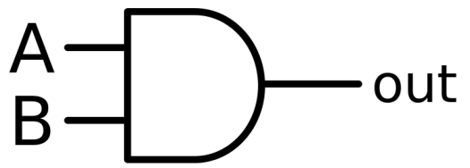 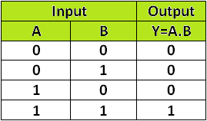

**Circuit Diagram and working:**

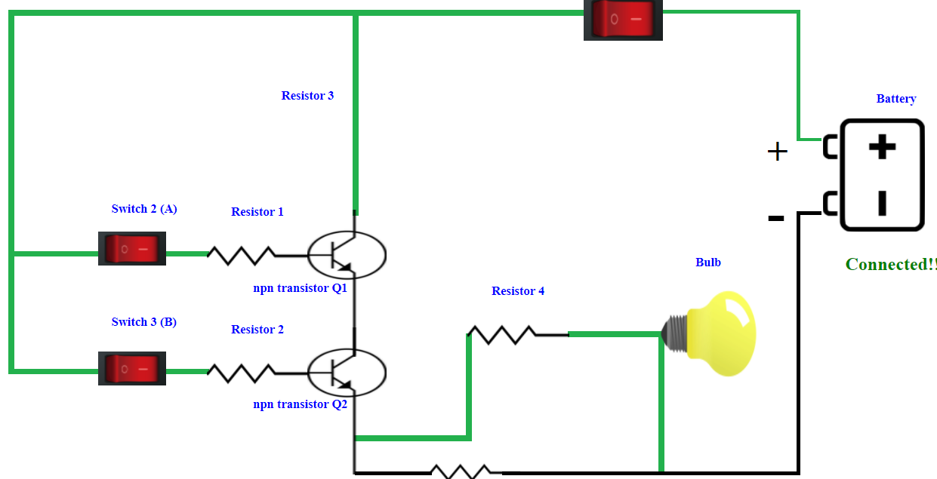

A simple 2-input logic AND gate can be constructed using RTL (Resistor-Transistor-Logic) switches connected together as shown below with the inputs connected directly to the transistor bases. Both transistors must be saturated “ON” for an output at Q.

**Result:**

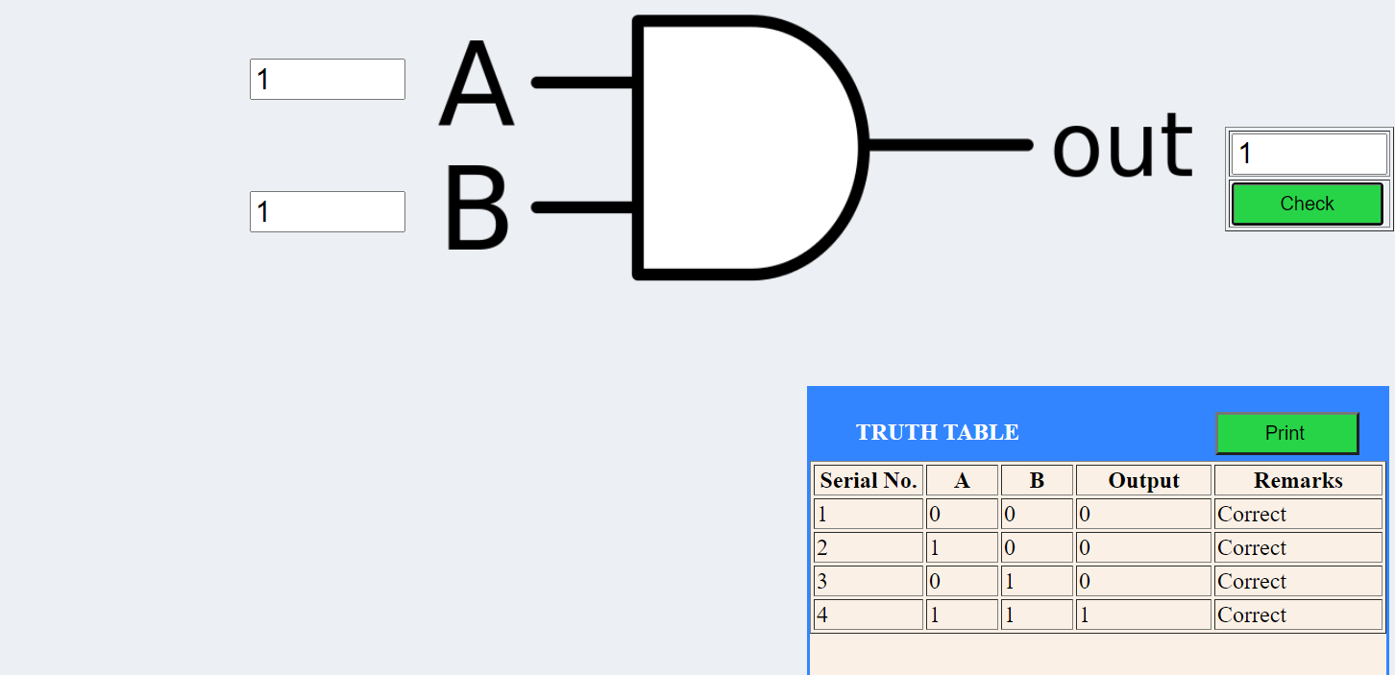

Fig: Implementation of AND Gate

**OR Gate:**

An OR gate is a logic gate that performs logical OR operation. A logical OR operation has a high output (1) if one or both the inputs to the gate are high (1). If neither input is high, a low output (0) results. Just like an AND gate, an OR gate may have any number of input probes but only one output probe.

**Symbol & Truth table:**

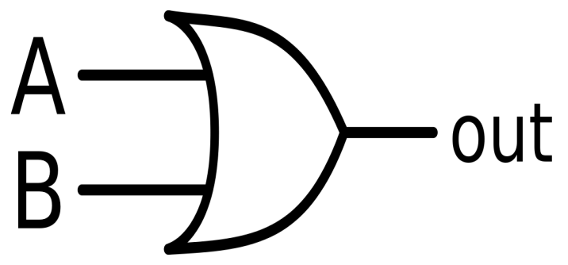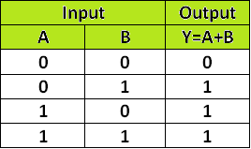

**Circuit Diagram and Its Working:**

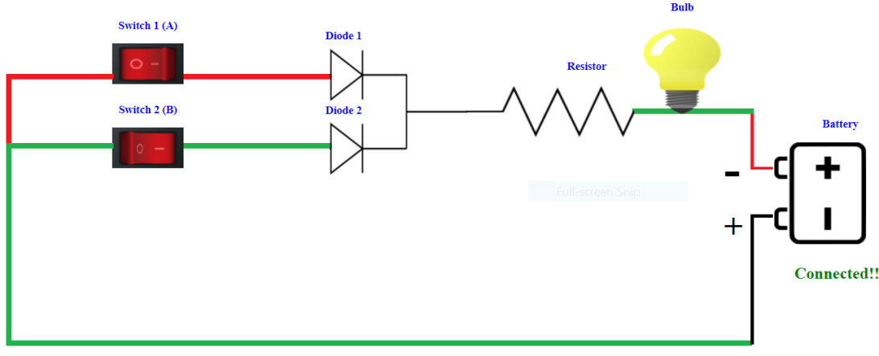

OR gate can be realized by DRL (Diode-Resistance-Logic) or by TTL (Transistor-Transistor-Logic). Presently, we will learn how to implement the OR gate using DRL (Diode-Resistance-Logic). To realise OR gate, we will use a diode at every input of the OR gate. The anode part of the diode is connected with input while the cathode part is joined together and a resistor, connected with the cathode is grounded. In this case, we have taken two inputs which can be seen in the circuit below. When both the inputs are at logic 0 or low state then the diodes D1 and D2 become reverse biased. Since the anode terminal of the diode is at a lower voltage level than the cathode terminal, the diode will act as an open circuit so there is no voltage across the resistor and hence output voltage is the same as ground. When either of the diodes is at logic 1 or high state then the diode corresponding to that input is forward bias. Since this time anode is at higher voltage than cathode therefore current will flow through forward biased diode and this current then appears on the resistor causing high voltage at output terminal also. Hence at output we get high or logic 1 or +5V. So, if any or both inputs are high, the output will be high or “1”.

**Result:**

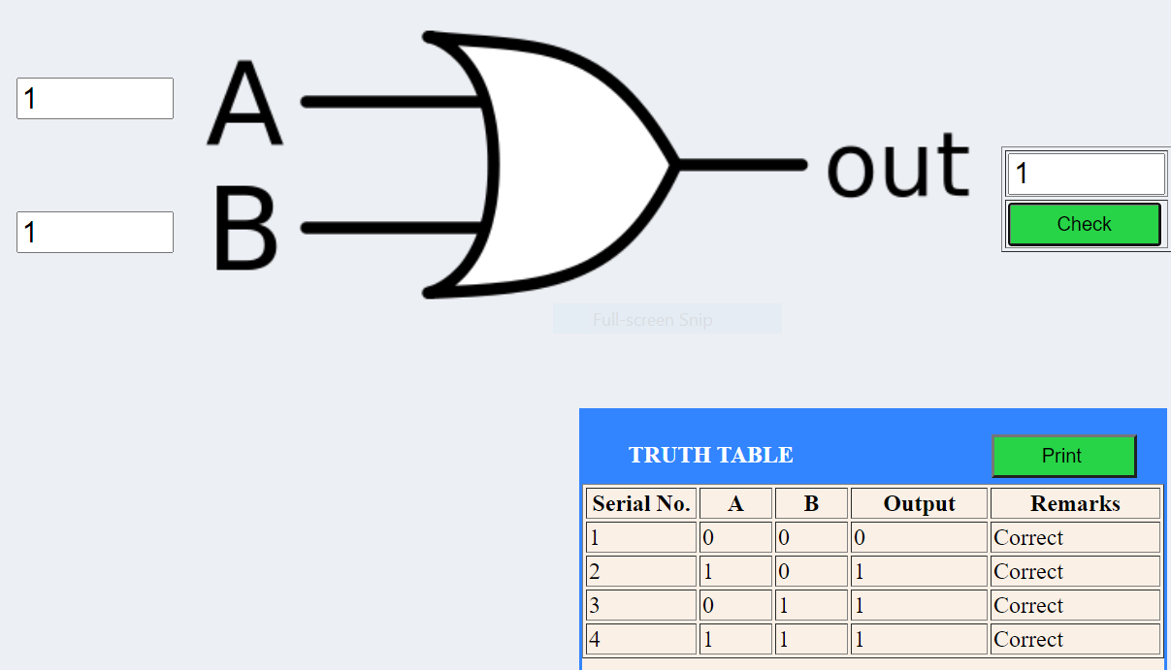

**NOT Gate:**

A NOT gate (also often called Inverter) is a logic gate. Each NOT gate has only one input signal. Logically with NOT gates, the input and the output swap, so if you input 1 it outputs as 0; likewise if you input 0 it outputs as 1.The NOT gate negates the values of data or signal in its input. It always outputs the opposite signal. Its main function is to interchange logic.

Symbol & Truth table:

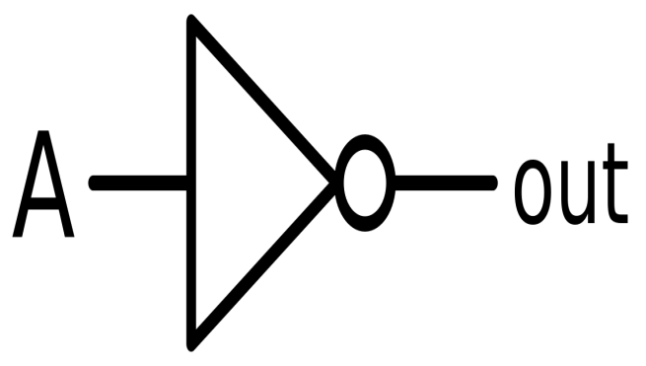 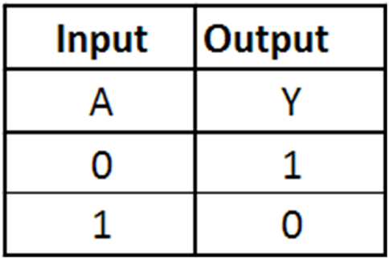

**Circuit Diagram & Its working:**

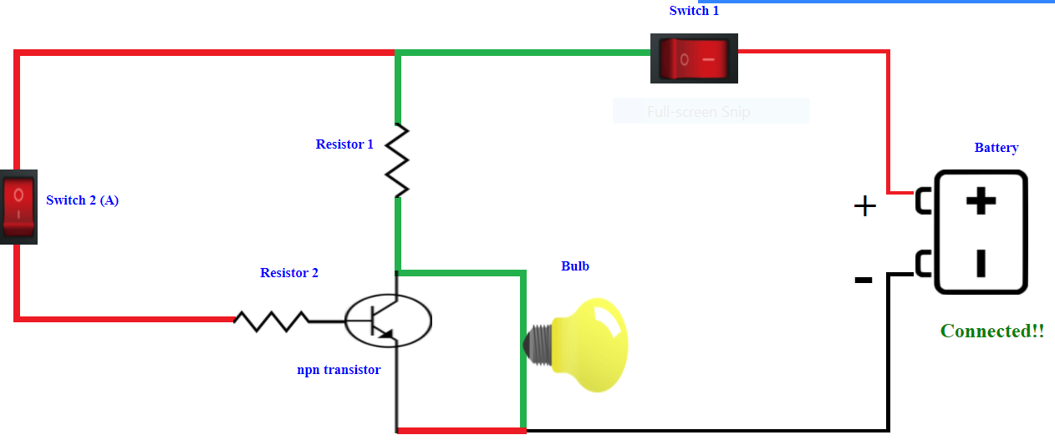

NOT gate can be realized through a transistor.The input is connected through resistor R2 to the transistor’s base. When no voltage is present on the input, the transistor turns off. When the transistor is off, no current flows through the collector-emitter path. Thus, current from the supply voltage (Vcc) flows through resistor R1 to the output. In this way, the circuit’s output is high when its input is low. When voltage is present at the input, the transistor turns on, allowing current to flow through the collector-emitter circuit directly to ground. This ground path creates a shortcut that bypasses the output, which causes the output to go low. In this way, the output is high when the input is low and low when the input is high.

**Output:**

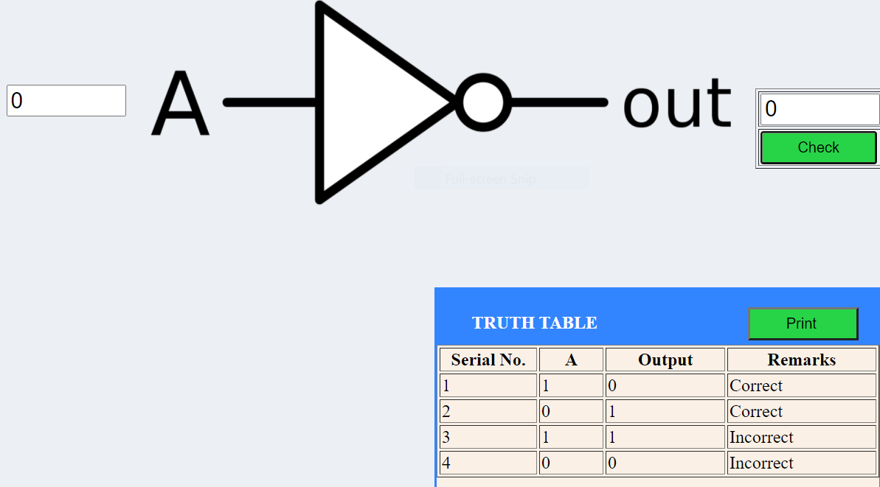

Implementation of NOT Gate

**NAND Gate:**

The NAND gate is a combination of an AND gate and NOT gate. They are connected in cascade form. It is also called Negated And gate. The NAND gate provides the false or low output only when their output is high or true. The NAND gate is essential because different types of a boolean function are implemented by using it. The NAND gate has the property of functional completeness. The function completeness means any types of gates can be implemented by using the NAND gate. It performs the function of OR, NOR and AND gates.

**Symbols & Truth Table:**

The logic symbol for the gate is shown below:

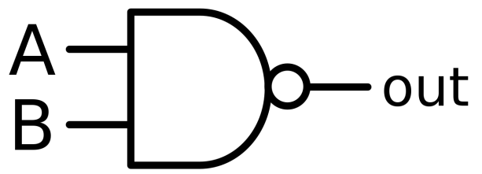 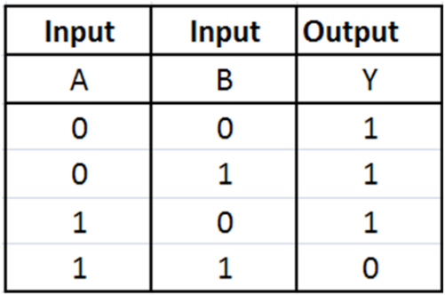

The equation is read as “Z equals NOT A AND B”. Since the logic circuit involves an AND gate followed by an inverter. The output can only be low when both the inputs are high.

**Circuit Diagram & working:**

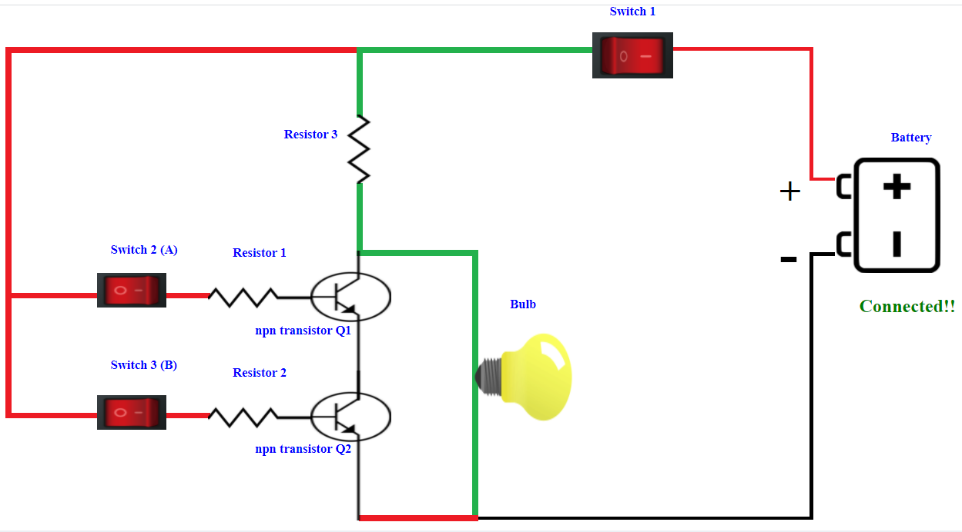

A simple 2-input logic NAND gate can be constructed using RTL (Resistor-transistor-logic) switches connected together as shown below with the inputs connected directly to the transistor bases. Either transistor must be cut-off or “OFF” for an output at Q.

**Result:**

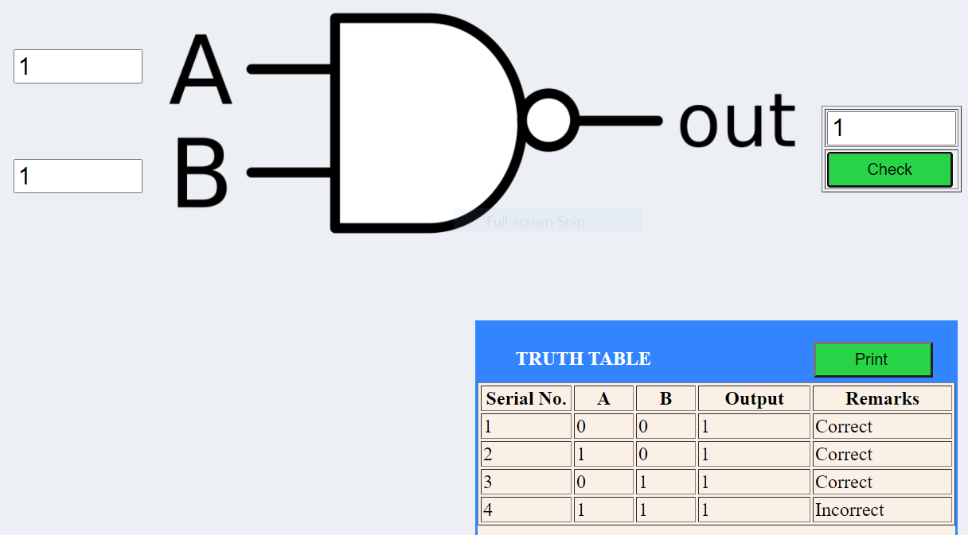

Implementation of Nor Gate

**NOR Gate:**

A NOR gate (“not OR gate”) is a logic gate that produces a high output (1) only if all its inputs are false, and low output (0) otherwise. Hence the NOR gate is the inverse of an OR gate, and its circuit is produced by connecting an OR gate to a NOT gate. Just like an OR gate, a NOR gate may have any number of input probes but only one output probe.A NOT gate followed by an OR gate makes a NOR gate.

**Symbol and Truth Table:**

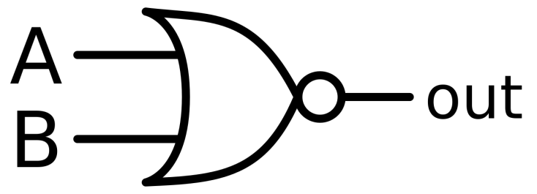 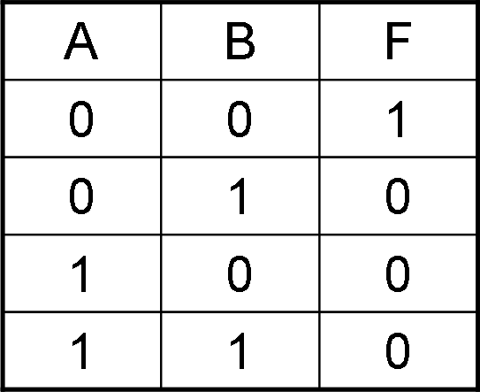

**Circuit Diagram and Truth Table:**

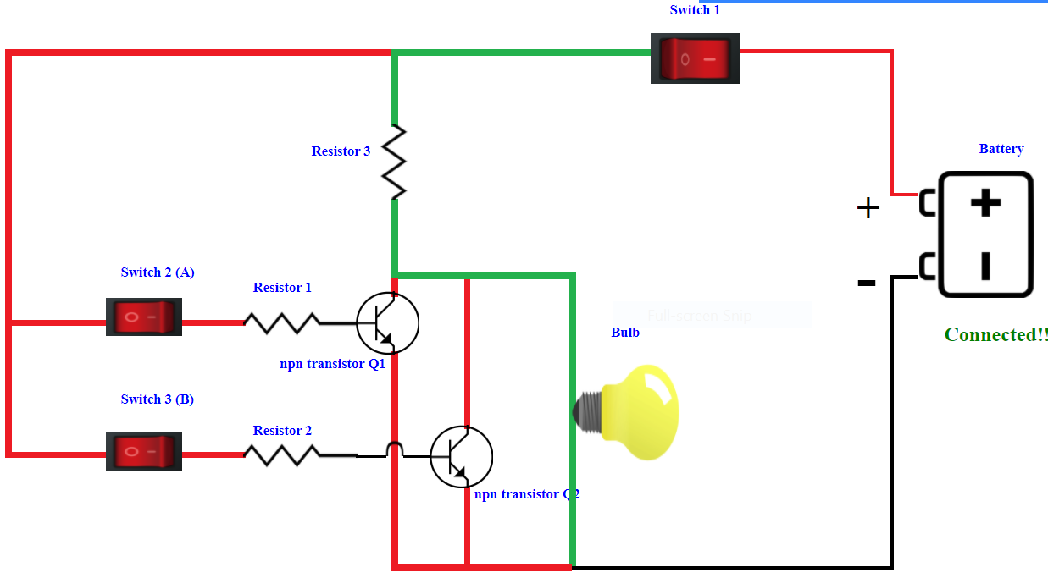

A simple 2-input logic NOR gate can be constructed using RTL (Resistor-transistor-logic) switches connected together as shown above with the inputs connected directly to the transistor bases. Both transistors must be cut-off or “OFF” for an output at Q.

**Result:**

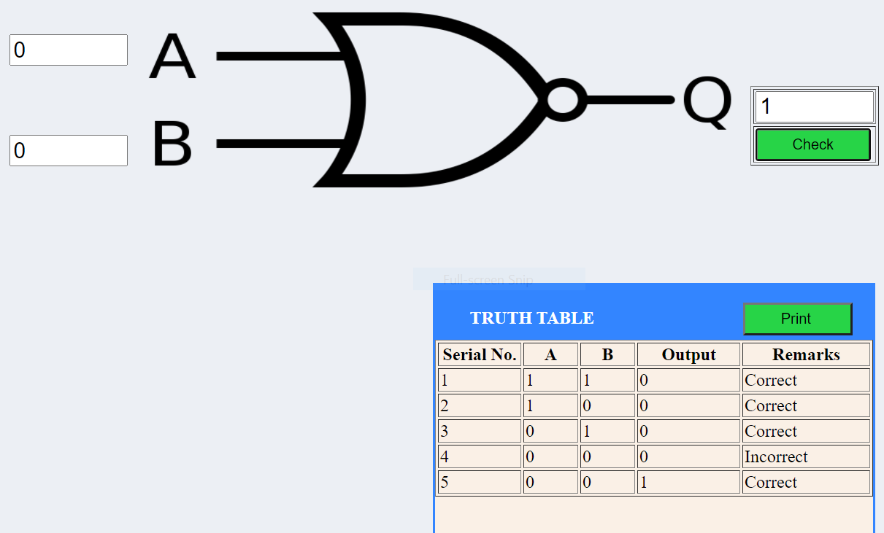

**EX-OR Gate:**

The EX-OR gate is used extensively in digital data processing circuits and is known as Exclusive-OR-gate. The EX-OR gate has a high output only when an odd number of inputs are high. For the two input EX-OR gates, the output will be high when the set of input is either 01 or 10.

The XOR gate is used in the adder, subtractor and controlled inverter circuit. It is also used in the computers for implementing the binary addition.

**Symbols and Truth Table:**

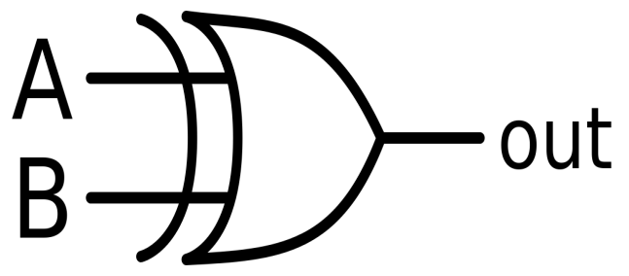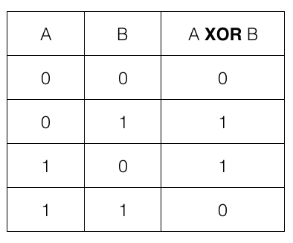

**Circuit Diagram and Working:Result:**

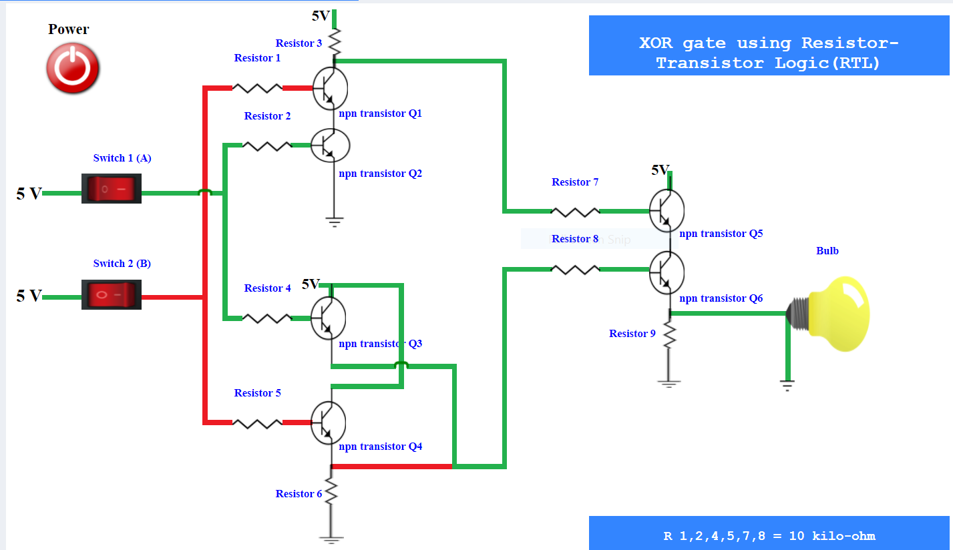

**Implementation of EX-OR Gate**

**EX-NOR Gate:**

The XNOR gate (also known as a XORN’T, ENOR, EX-NOR or N-XOR) – and pronounced as Exclusive NOR – is a digital logic gate whose function is the logical complement of the exclusive OR gate (XOR gate). Logically, an XNOR gate is a NOT gate followed by an XOR gate. The XOR operation of inputs A and B is A ⊕ B; therefore, XNOR operation those inputs will be (A + B) ̅. That means the output of the XOR gate is inverted in the XNOR gate. The XNOR gate, the inverse is true. Hence the output is 0 when only one input is 0, and the output is 1 when both inputs are the same (i.e. either two 0’s or two 1’s).

**Symbol & Truth Table:**

 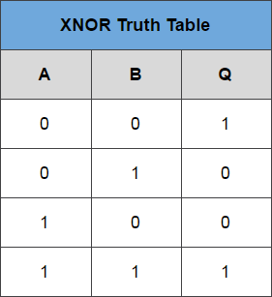

**Circuit Diagram and Working:**

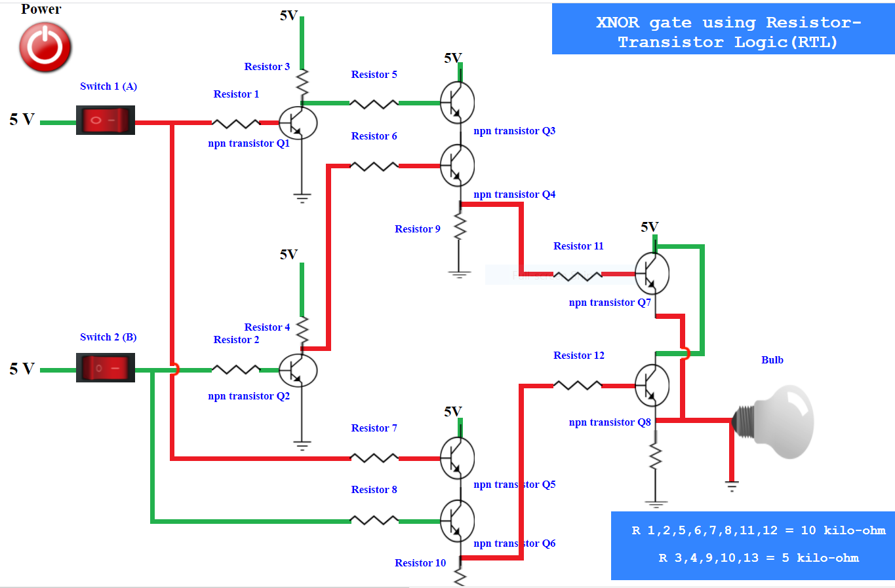

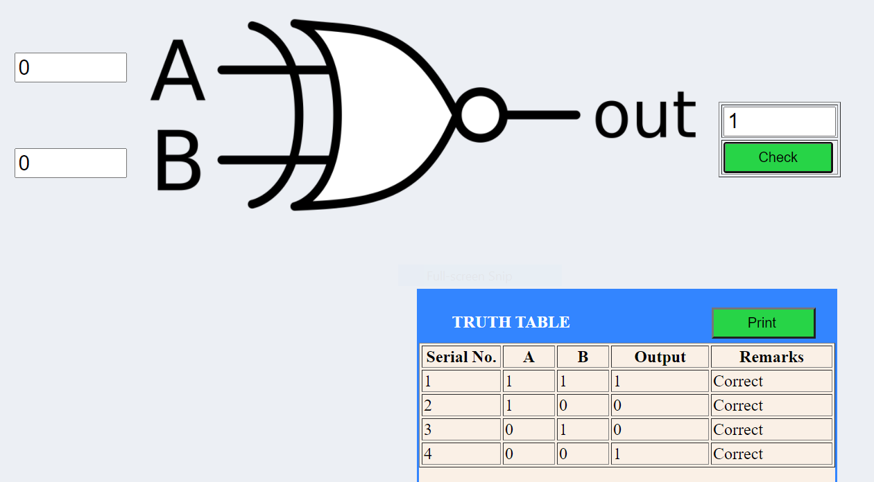

It will give a low output if either, but not both of its two inputs are high. The symbol is an EX-OR gate with a small circle on the output. The small circle represents inversion.

**Result:**

**Implementation of EX-NOR Gate**

**Conclusion:**

From the above experiment that we perform in the virtual lab we get to learn about the working of different universal as well as basic logic gates. Also we get to learn how the ic circuit works using logic gates and so on.

**********

**Experiment-2**

**Aim:**

#### To verify the truth table of half adder and full adder by using XOR and NAND gates respectively and analyse the working of half adder and full adder circuit with the help of LEDs in simulator 1 and verify the truth table only of half adder and full adder in simulator 2.

**Theory:**

An adder is a [digital logic circuit](https://www.elprocus.com/different-types-of-digital-logic-circuits/) in electronics that is extensively used for the addition of numbers. In many computers and other types of processors, adders are even used to calculate addresses and related activities and calculate table indices in the ALU and even utilized in other parts of the processors. These can be built for many numerical representations like excess-3 or binary coded decimal. Adders are basically classified into two types:

* Half Adder and
* Full Adder.

Half Adder:

The half adder circuit has two inputs: A and B, which add two input digits and generate a carry and a sum. It adds two binary digits where the input bits are termed as augend and addend and the result will be two outputs one is the sum and the other is carry. To perform the sum operation, XOR is applied to both the inputs, and AND gate is applied to both inputs to produce carry.

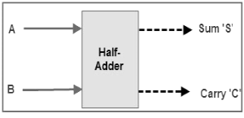 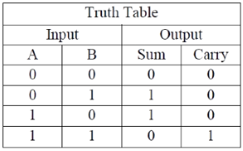

**Figure 1. Block diagram and truth table of half adder**

The same can be verified with help of Karnaugh Map.

The truth table and K Map simplification and logic diagram for sum output is shown below.

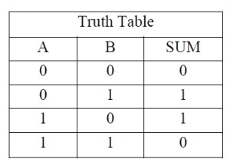 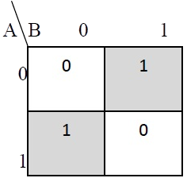 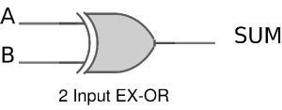

Figure 2. Truth table, K Map simplification and Logic diagram for sum output of half adder.

Sum = A B' + A' B

The truth table and K Map simplification and logic diagram for carry is shown below.

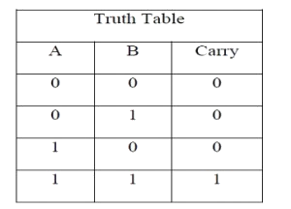 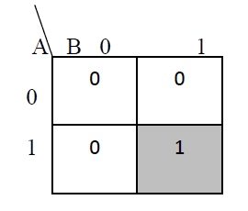 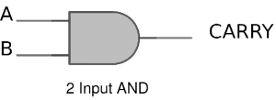

Figure 3. Truth table, K Map simplification and Logic diagram for sum output of half adder.

Carry = AB

If A and B are binary inputs to the half adder, then the logic function to calculate sum S is Ex – OR of A and B and the logic function to calculate carry C is AND of A and B.

Combining these two, the logical circuit to implement the combinational circuit of half adder is shown below.

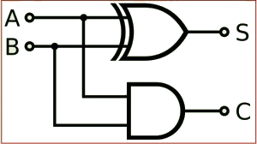

Figure 4. Half Adder Logic Diagram

As we know that NAND and NOR are called universal gates as any logic system can be implemented using these two, the half adder circuit can also be implemented using them. We know that a half adder circuit has one Ex – OR gate and one AND gate.

**1.1)Half Adder using NAND gates**

Five NAND gates are required in order to design a half adder. The circuit to realize half adder using NAND gates is shown below.

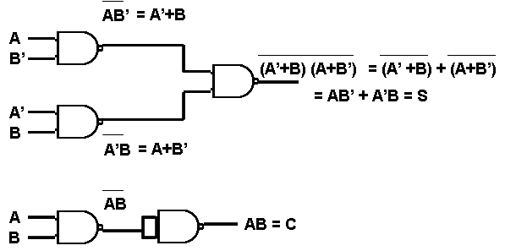

Figure 5. Realization of half adder using NAND gates.

### **1.2)Half Adder using NOR gates**

### Five NOR gates are required in order to design a half adder. The circuit to realize half adder using NOR gates is shown below.

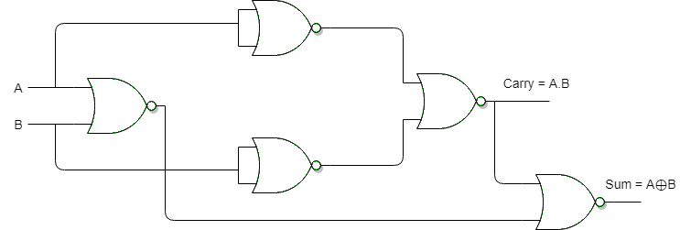

**Figure 6. Realization of half adder using NOR Gates**

**IC Number Of Half Adder:**

The implementation of half adder can be done through high-speed CMOS digital logic integrated circuits like 74HCxx series which includes the SN74HC08 (7408) & SN74HC86 (7486).

Full Adder:

This adder is difficult to implement when compared to half-adder.

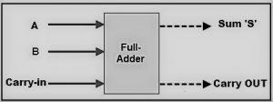

Fig.7 Full Adder Functional Diagram

The difference between a half-adder and a full-adder is that the full-adder has three inputs and two outputs, whereas a half adder has only two inputs and two outputs. The first two inputs are A and B and the third input is an input carry as C-IN. When a full-adder logic is designed, we string eight of them together to create a byte-wide adder and cascade the carry bit from one adder to the next.

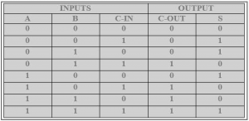

Fig.8 Truth table for Full Adder

The output carry is designated as C-OUT and the normal output is represented as S which is ‘SUM’.

With the above **full adder truth-table**, the implementation of a full adder circuit can be understood easily. The SUM ‘S’ is produced in two steps:

1. By XORing the provided inputs ‘A’ and ‘B’
2. The result of A XOR B is then XORed with the C-IN

This generates SUM and C-OUT is true only when either two of three inputs are HIGH, then the C-OUT will be HIGH. So, we can implement a full adder circuit with the help of two half adder circuits. Initially, the half adder will be used to add A and B to produce a partial Sum and a second-half adder logic can be used to add C-IN to the Sum produced by the first half adder to get the final S output.

If any of the half adder logic produces a carry, there will be an output carry. So, C-OUT will be an OR function of the half-adder Carry outputs. Take a look at the implementation of the full adder circuit shown below.

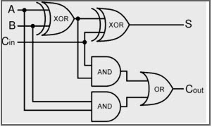

Fig.8 Logic Diagram of Full Adder

The implementation of larger logic diagrams is possible with the above full adder logic; a simpler symbol is mostly used to represent the operation.

Based on the truth table, the Boolean functions for Sum (S) and Carry – out (COUT) can be derived using K – Map.

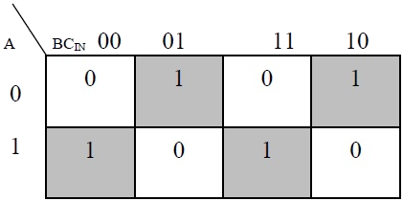

Figure 10. The K-Map simplified equation for sum is S = A'B'Cin + A'BCin' + ABCin

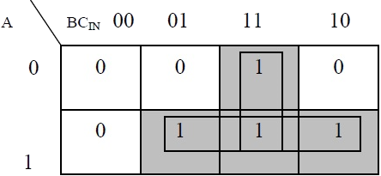

Figure 11. The K-Map simplified equation for COUT is COUT = AB + ACIN + BCIN

In order to implement a combinational circuit for full adder, it is clear from the equations derived above, that we need four 3-input AND gates and one 4-input OR gates for Sum and three 2-input AND gates and one 3-input OR gate for Carry – out.

### 2.1)Full Adder using NAND gates:

As mentioned earlier, a NAND gate is one of the universal gates and can be used to implement any logic design. The circuit of full adder using only NAND gates is shown below.

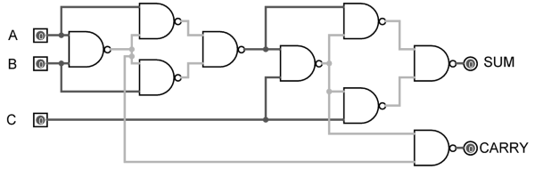

Figure 9. Full Adder using NAND gates

### 2.2)Full Adder using NOR gates:

As mentioned earlier, a NOR gate is one of the universal gates and can be used to implement any logic design. The circuit of full adder using only NOR gates is shown below.

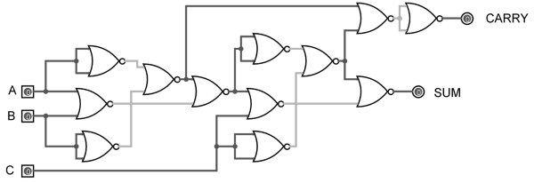

Figure 10. Full Adder using NOR gates

**Observation and Result:**

Half adder:

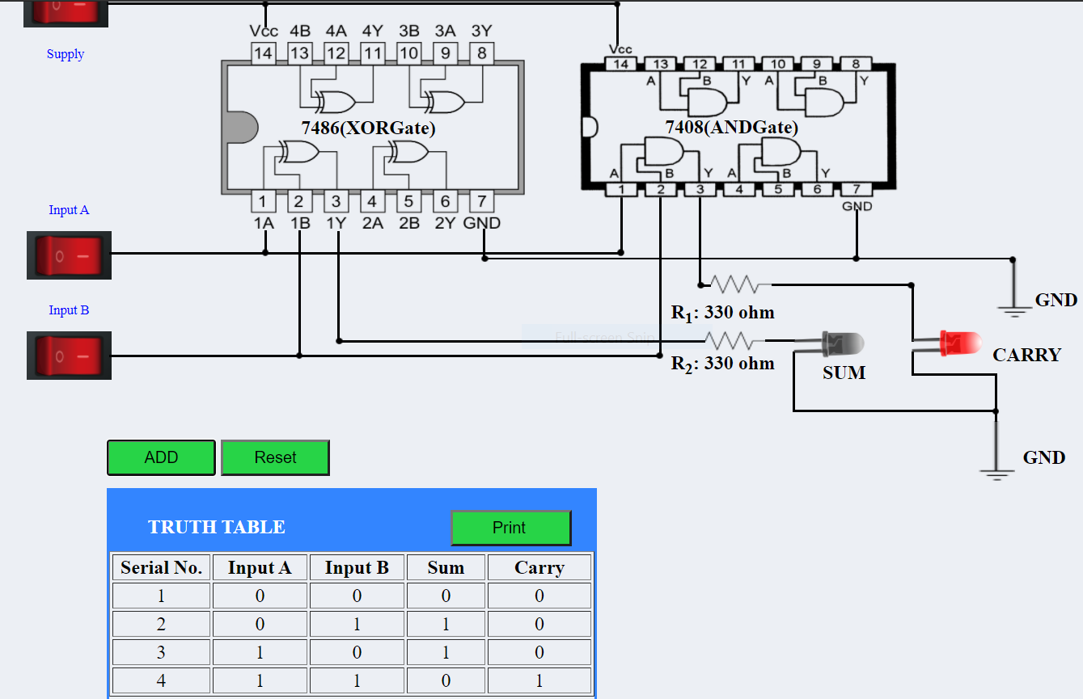

Full adder:

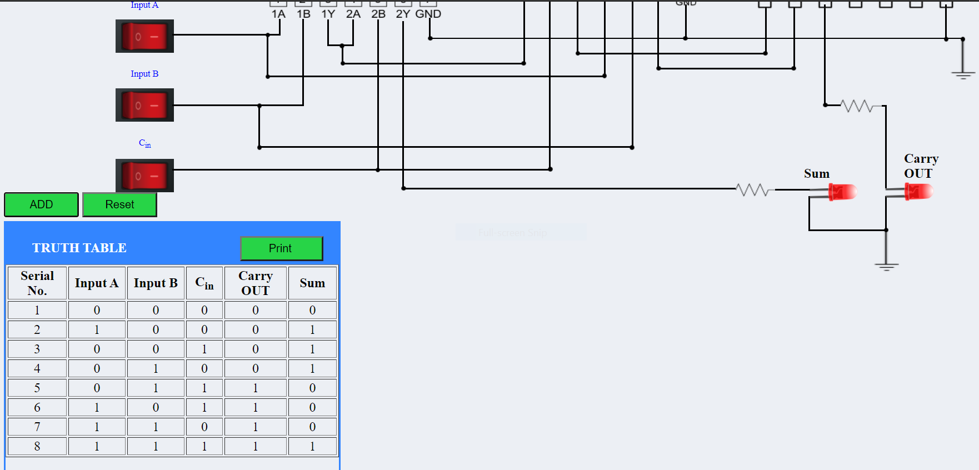

**Verification of Truth Table:**

Half adder:

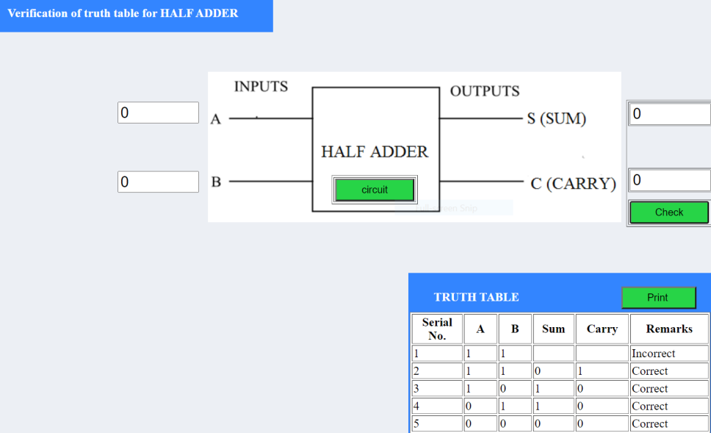

Full Adder:

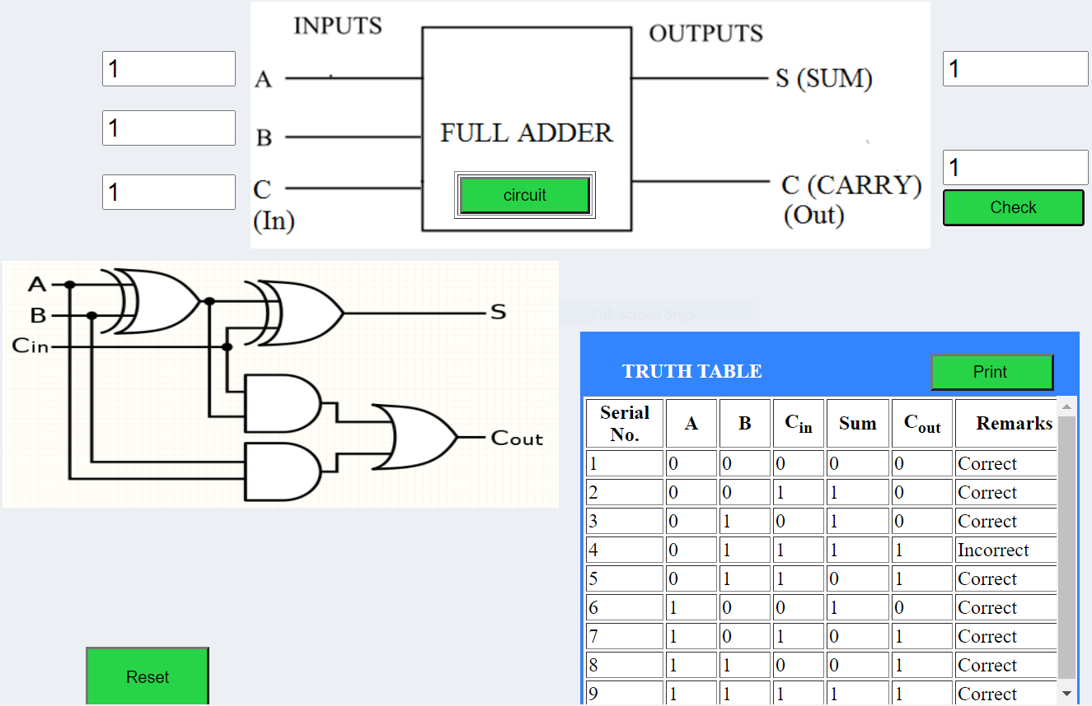

**Conclusion:**

From the above experiment that we perform in the virtual lab we get to learn about the working of half adder and full adder. Also we get to learn that how the cons of half adder can be removed by replacing it with full adders

***********

**Experiment-3**

**Aim:**

To verify the truth table of half subtractor by using the ICs of XOR, NOT and AND gates and of full subtractor by using the ICs of XOR, AND, NOT and OR gates respectively and analyse the working of half subtractor and full subtractor circuit with the help of LEDs in simulator 1 and verify the truth table only of half subtractor and full subtractor in simulator 2.

**Theory:**

The Binary Subtractor is another type of combinational arithmetic circuit that produces an output which is the subtraction of two binary numbers.

Unlike the Binary Adder which produces a SUM and a CARRY bit when two binary numbers are added together, the binary subtractor produces a DIFFERENCE, D by using a BORROW bit, B from the previous column. Then obviously, the operation of subtraction is the opposite to that of addition.

There are two types of subtractors.

1) Half Subtractor

2) Full Subtractor

**Half Subtractor:**

In binary subtraction, the process of subtraction is similar to arithmetic subtraction. In arithmetic subtraction the base 2 number system is used whereas in binary subtraction, binary numbers are used for subtraction. The resultant terms can be denoted with the difference and borrow.

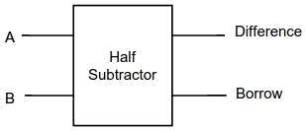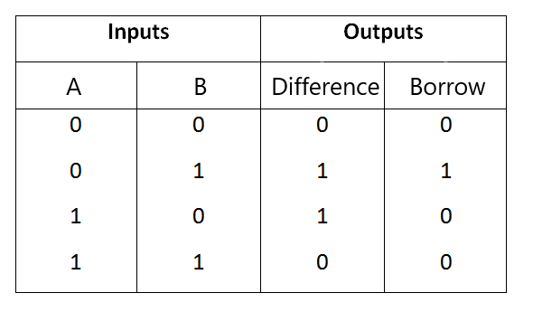

**Fig-1:Logic Symbol of half subtractor**  **Fig-2:Truth Table of half subtractor**

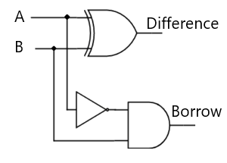

**Fig-3:Circuit diagram of half subtractor**

Half subtractor is the most essential [combinational logic circuit](https://www.elprocus.com/introduction-to-combinational-logic-circuits/) which is used in [digital electronics](https://www.elprocus.com/digital-electronics-flip-flop-circuit-types-and-applications/). Basically, this is an electronic device or in other terms, we can say it as a logic circuit. This circuit is used to perform two binary digits subtraction.The subtractor circuit uses binary numbers (0,1) for the subtraction. The circuit of the half subtractor can be built with two [logic gates namely NAND and EX-OR gates](https://www.elprocus.com/basic-logic-gates-with-truth-tables/). This circuit gives two elements such as the difference as well as they borrow.

From the above truth table we can find the boolean expression:

Difference = A ⊕ B

Borrow = A' B

**Full Subtractor:**

A full subtractor is a **combinational circuit** that performs subtraction of two bits, one is minuend and other is subtrahend, taking into account borrow of the previous adjacent lower minuend bit. This circuit **has three inputs and two outputs**. The three inputs A, B and Bin, denote the minuend, subtrahend, and previous borrow, respectively. The two outputs, D and Bout represent the difference and output borrow, respectively.

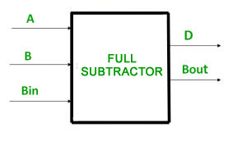 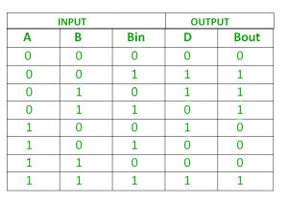

**Fig-4:Logic Symbol for Full subtractor Fig-5:Truth table for Full subtractor**

From the above table we can draw the K-Map as shown for “difference” and “borrow”.

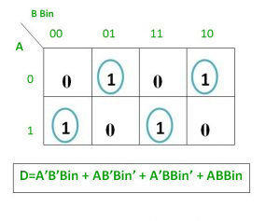

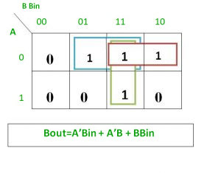

**Logical expression for difference –**

D = A’B’Bin + A’BBin’ + AB’Bin’ + ABBin

= Bin(A’B’ + AB) + Bin’(AB’ + A’B)

= Bin( A XNOR B) + Bin’(A XOR B)

= Bin (A XOR B)’ + Bin’(A XOR B)

= Bin XOR (A XOR B)

= (A XOR B) XOR Bin

**Logical expression for borrow –**

Bout = A’B’Bin + A’BBin’ + A’BBin + ABBin

= A’B’Bin +A’BBin’ + A’BBin + A’BBin + A’BBin + ABBin

= A’Bin(B + B’) + A’B(Bin + Bin’) + BBin(A + A’)

= A’Bin + A’B + BBin

OR

Bout = A’B’Bin + A’BBin’ + A’BBin + ABBin

= Bin(AB + A’B’) + A’B(Bin + Bin’)

= Bin( A XNOR B) + A’B

= Bin (A XOR B)’ + A’B

**Logic Circuit for Full Subtractor –**

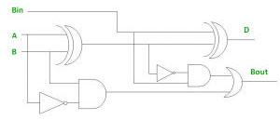

**Procedure:**

1)HALF SUBTRACTOR

Simulator 1:

Step-1)The Supply(+5V)  to the circuit was connected.

Step-2) "ADD" button to add basic state of your output in the given table was pressed firstly

Step-3) The switches to select the required inputs "A" and "B" was pressed.

Step-4)"ADD" button to add your inputs and outputs in the given table was pressed

Step-5)Steps 3&4 for next state of inputs and their corresponding outputs was repeated.

Step-6)The "PRINT" button after completing your simulation to get your results was pressed.

Simulator 2:

Step-1) The Boolean input "A" and "B" was entered.

Step-2)The Boolean output for your corresponding inputs was entered

Step-3) "Check" Button to verify your output was clicked on.

Step-4)"Print" if you wanted to get print out of Truth Table was clicked

Step-5)"Reset" if you wanted to reset inputs and outputs was clicked.

**2)FULL SUBTRACTOR**

Simulator 1:

Step-1)The Supply(+5V)  the circuit was connected.

Step-2)"ADD" button to add the basic state of our output in the given table was pressed.

Step-3) The switches to select the required inputs "A" and "B" and "Bin" were pressed.

Step-4)"ADD" button to add your inputs and outputs in the given table was pressed.

Step-5)Steps 3&4 for the next state of inputs and their corresponding outputs was repeated.

Step-6)"PRINT" button after completing our simulation to get your results was pressed.

Simulator 2:

Step-1)The Boolean inputs "A" and "B" and "Bin" were entered.

Step-2)The Boolean output for your corresponding inputs was entered.

Step-3)"Check" Button to verify your output was clicked on

Step-4)"Print" if you want to get print out of Truth Table was clicked on.

Step-5)"Reset" if you want to reset inputs and outputs was clicked.

**Implementation of Half Subtractor circuit:**

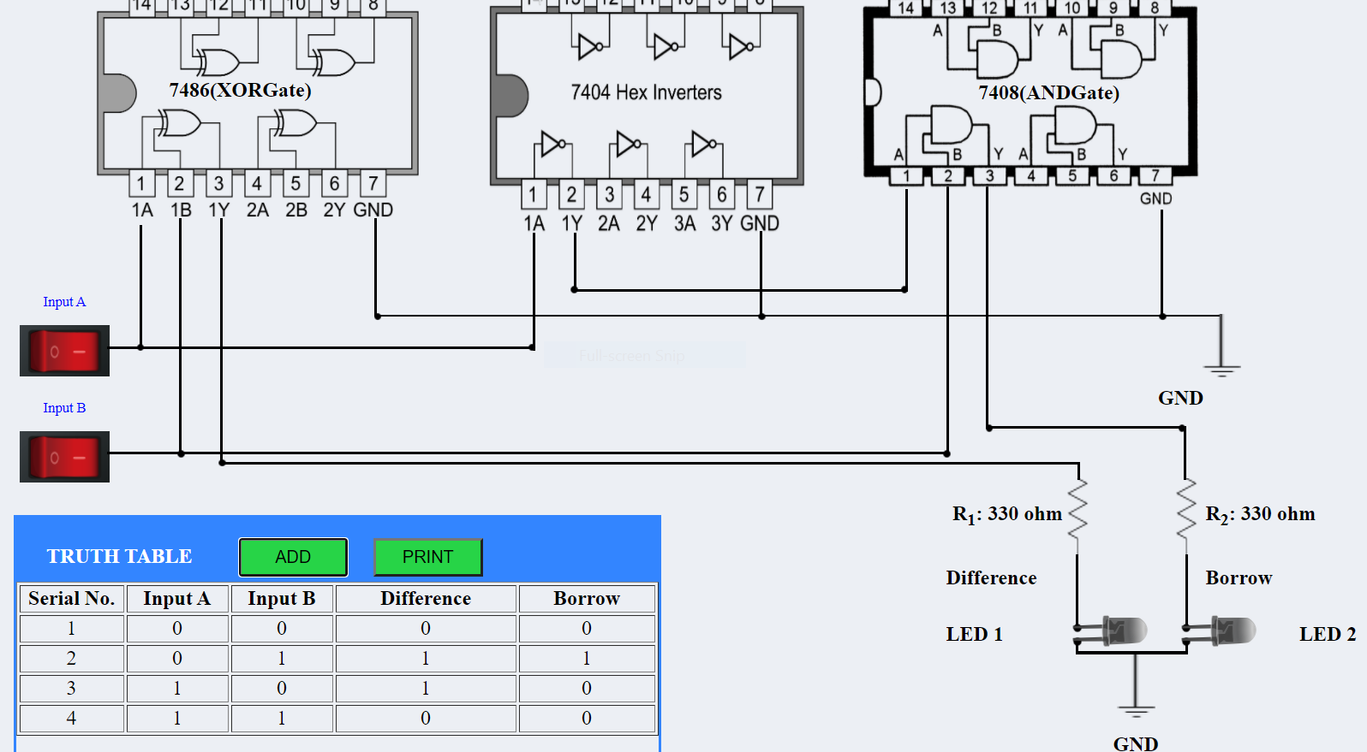

**Implementation of full subtractor circuit:**

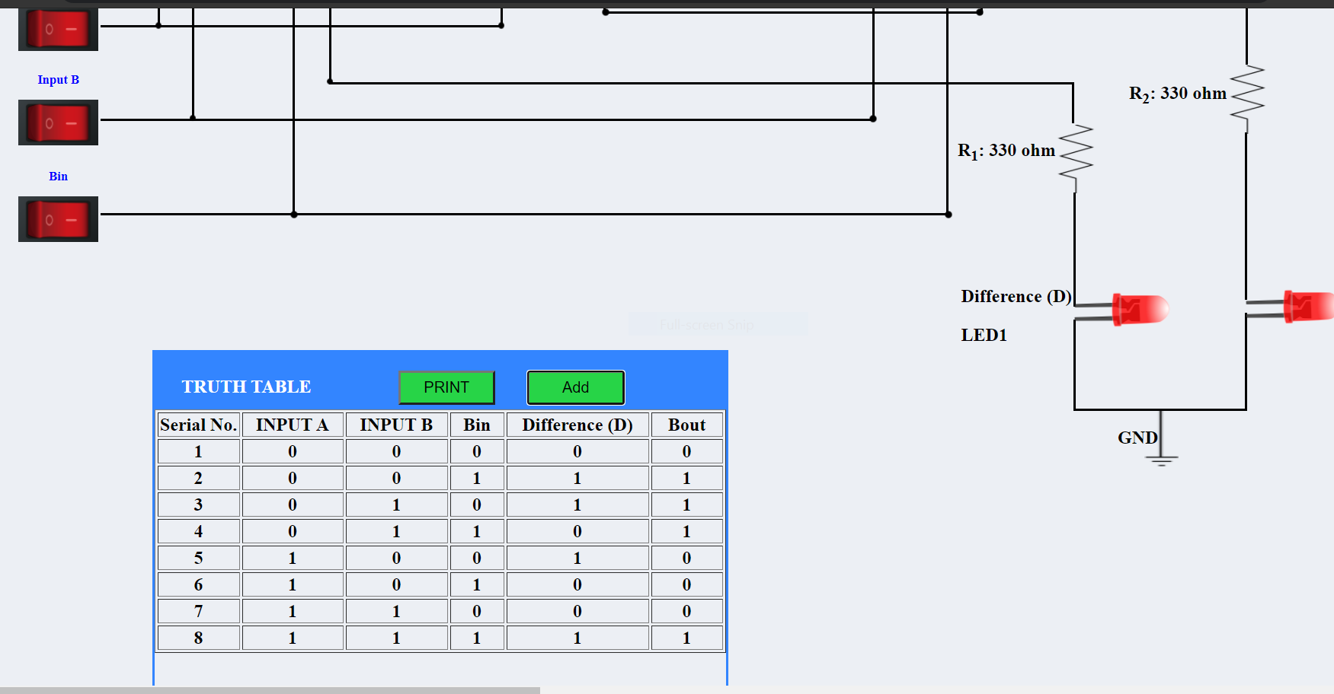

**Verification with help of truth table:**

**Half subtractor**

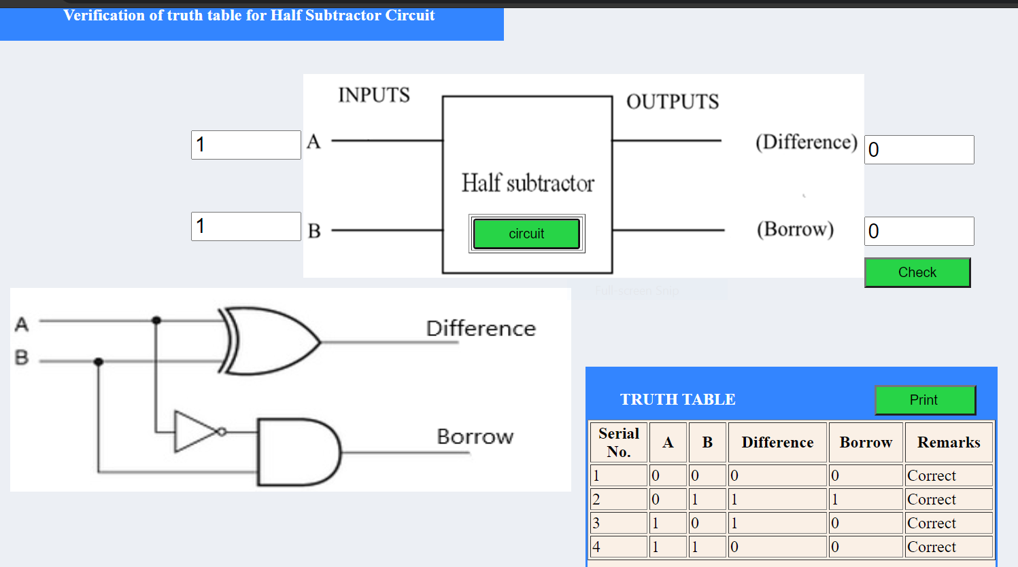

**Full subtractor:**

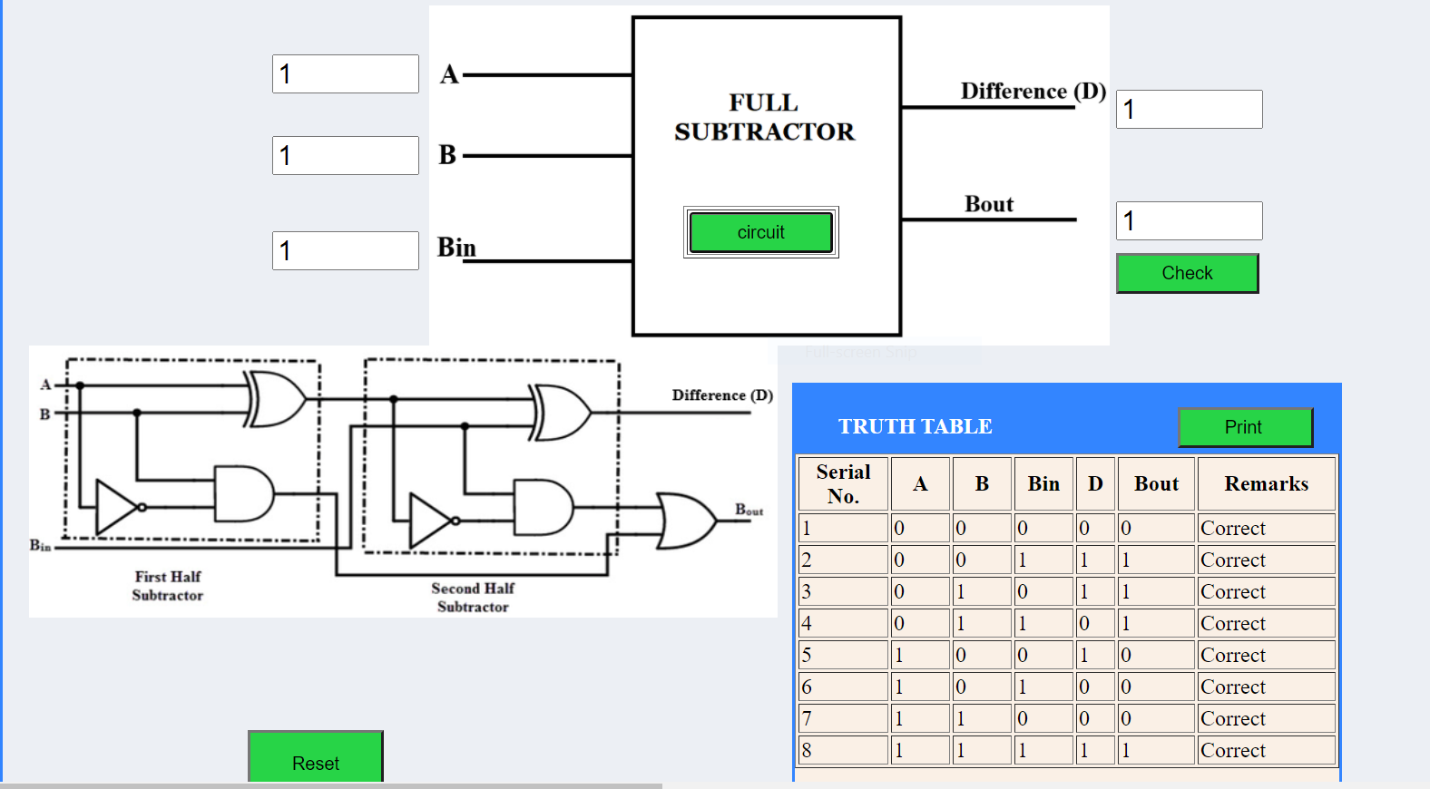

**Conclusion:**

From the above experiment that we perform in the virtual lab we get to learn about the working of half subtractor and full subtractor. Also we get to learn how the cons of the half subtractor can be removed by replacing it with full subtractor.

***********

**Experiment-4**

**Aim:**

To implement the logic functions i.e. AND, OR, NOT, Ex-OR, Ex- NOR and a logical expression with the help of NAND and NOR universal gates respectively.

**Theory:**

A universal gate is a gate which can implement any Boolean function without need to use any other gate type. The **NAND** and **NOR** gates are universal gates. In practice, this is advantageous since NAND and NOR gates are economical and easier to fabricate and are the basic gates used in all IC digital logic families.

**NAND Gate as Universal gate:**

The NAND gate represents the complement of the AND operation. Its name is an abbreviation of NOT AND. The graphic symbol for the NAND gate consists of an AND symbol with a bubble on the output, denoting that a complement operation is performed on the output of the AND gate.

The truth table and the graphic symbol of NAND gate is shown in the figure:

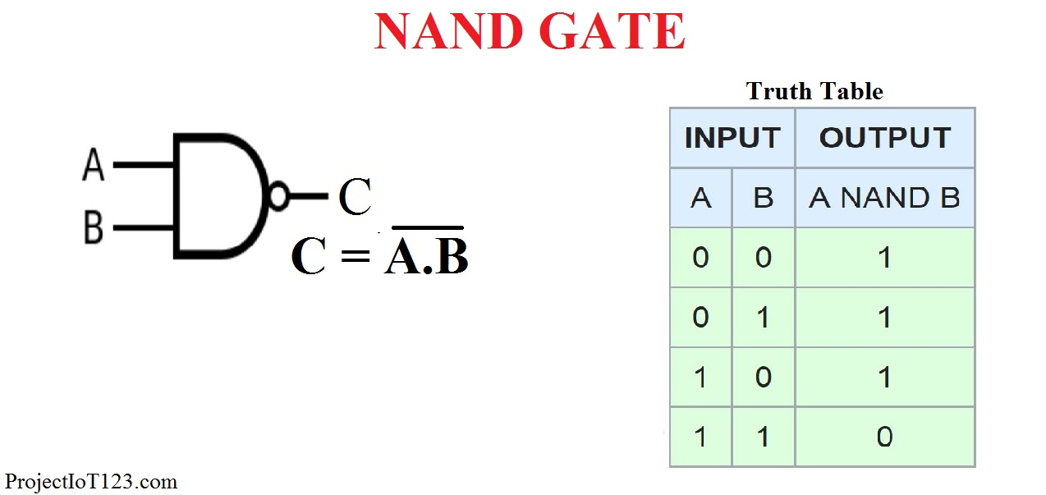

This gate can have a minimum of two inputs. By using only NAND gates, we can realize all logic functions: AND, OR, NOT, Ex-OR, Ex-NOR, NOR. So this gate is also called a universal gate.

1.1)NAND gates as OR gate:

From DeMorgan’s theorems:

(A.B)’ = A’ + B’

(A’.B’)’ = A’’ + B’’ = A + B

So, give the inverted inputs to a NAND gate, obtain OR operation at output.

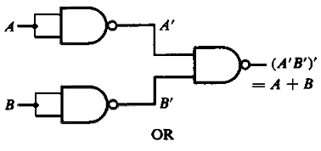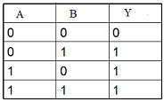

**Figure-1:NAND gates as OR gate Figure-2:Truth table of OR**

#### 

#### **1.2)NAND gates as AND gate**

A NAND produces a complement of AND gate. So, if the output of a NAND gate is inverted, overall output will be that of an AND gate.

**Y = ((A.B)’)’**

**Y = (A.B)**

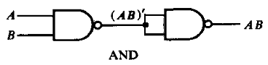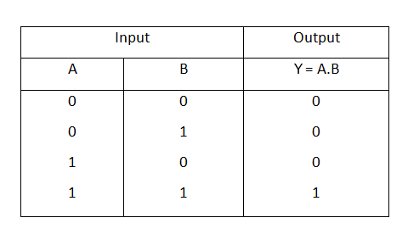

**Figure-3:NAND gates as AND gate Figure-4:Truth table of AND**

#### 

#### 

#### 

#### **1.3)NAND gates as Ex-OR gate**

The output of a two input Ex-OR gate is shown by: Y = A’B + AB’. This can be achieved with the logic diagram shown in the left side.

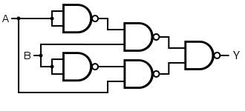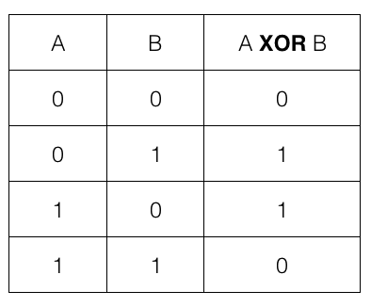

**Figure-5:NAND gate as Ex-OR gate Figure-6:Truth table of Ex-OR**

#### **1.4)NAND gates as Ex-NOR gate**

Ex-NOR gate is actually Ex-OR gate followed by NOT gate. So give the output of Ex-OR gate to a NOT gate, overall output is that of an Ex-NOR gate.

**Y = AB+ A’B’**

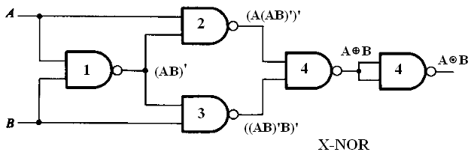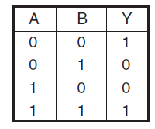

**Figure-7:NAND gates as Ex-NOR gate Figure-8:Truth table of Ex-NOR**

#### **1.5) Implementing the simplified function with NAND gates only**

We can now start constructing the circuit. First note that the entire expression is inverted and we have three terms ANDed. This means that we must use a 3-input NAND gate. Each of the three terms is, itself, a NAND expression. Finally, negated single terms can be generated with a 2-input NAND gate acting as an inverted. Figure 8 illustrates a circuit using NAND gates only.

**F=((C'.B.A)'(D'.C.A)'(C.B'.A)')'**

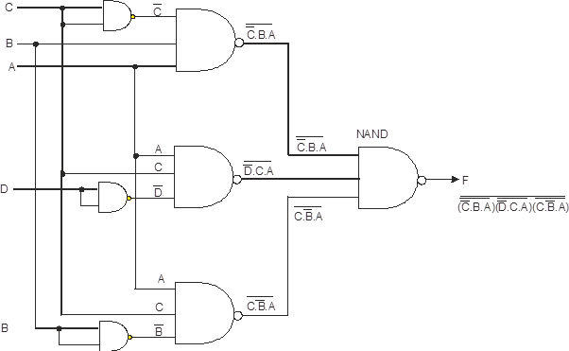

**Figure-9:Implementing the simplified function with NAND gates only**

**NOR Gate:**

The NOR or “Not OR” gate is also a combination of two separate logic functions, Not and OR connected together to form a single logic function which is the same as the OR function except that the output is inverted.

To create a NOR gate, the OR function and the NOT function are connected together in series with its operation given by the Boolean expression as, A + B

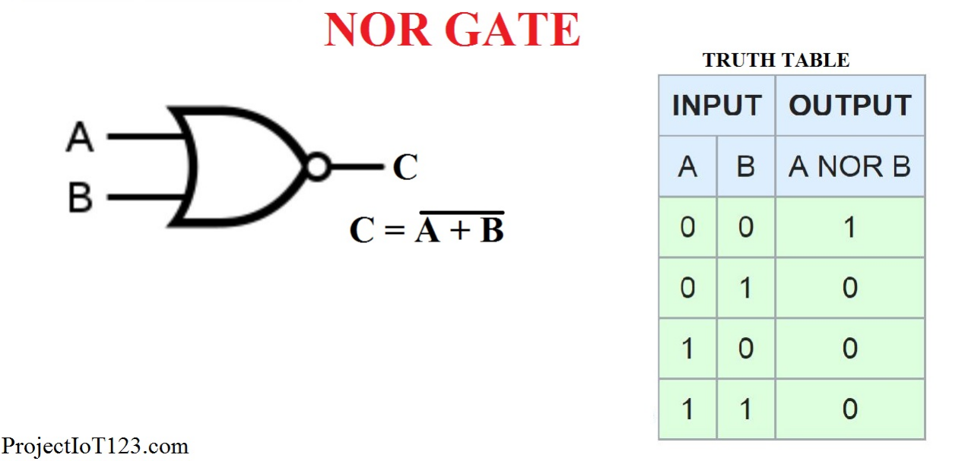

By using only NOR gates, we can realize all logic functions: AND, OR, NOT, Ex-OR, Ex-NOR, NAND. So this gate is also called a universal gate.

#### 

#### **2.1)NOR gates as OR gate**

A NOR produces a complement of OR gate. So, if the output of a NOR gate is inverted, overall output will be that of an OR gate.

**Y = ((A+B)’)’**

**Y = (A+B)**

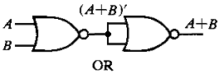 

**Figure-10:NOR gates as OR gate Figure-11:Truth table of OR**

#### 

#### 

#### **2.2)NOR gates as AND gate**

From DeMorgan’s theorems:

(A+B)’ = A’B’

(A’+B’)’ = A’’B’’ = AB

So, give the inverted inputs to a NOR gate, obtain AND operation at output.

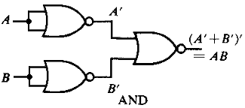 

**Figure-12:NOR gates as AND gate Figure-13:Truth table of AND**

#### **2.4)NOR gates as Ex-OR gate**

Ex-OR gate is actually Ex-NOR gate followed by NOT gate. So give the output of Ex-NOR gate to a NOT gate, overall output is that of an Ex-OR gate.

Y = A’B+ AB’

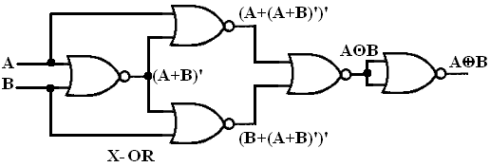

**Figure-14:NOR gates as Ex-OR gate Figure-15:Truth table of Ex-OR**

#### **2.3)NOR gates as Ex-NOR gate**

The output of a two input Ex-NOR gate is shown by: Y = AB + A’B’. This can be achieved with the logic diagram shown in the left side.

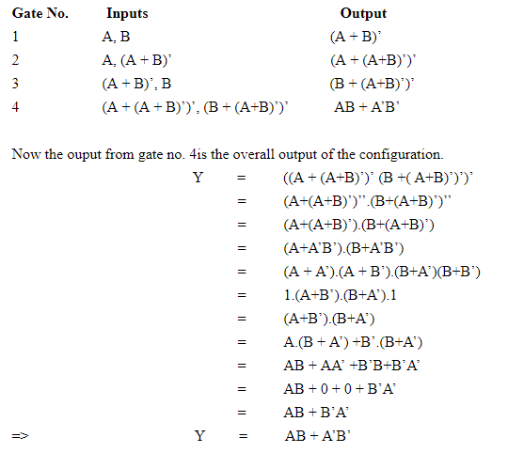

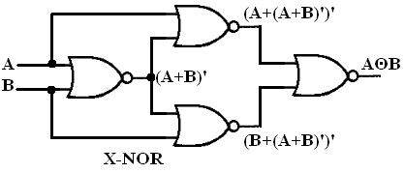 

**Figure-16:NOR gates as Ex-NOR gate Figure-17:Truth table of Ex-NOR**

#### 

#### **2.5)Constructing a circuit with NOR gates only**

Designing a circuit with NOR gates only uses the same basic techniques as designing a circuit with NAND gates; that is, the application of deMorgan’s theorem. The only difference between NOR gate design and NAND gate design is that the former must eliminate product terms and the later must eliminate sum terms.

**F=(((C.B'.A)+(D.C'.A)+(C.B'.A))')'**

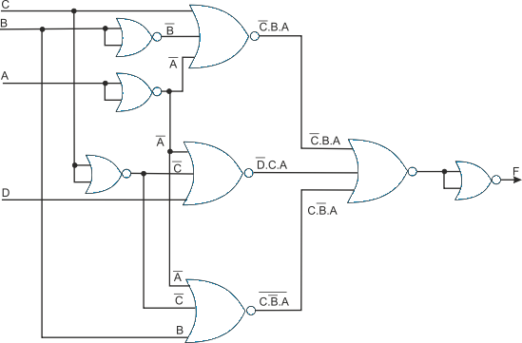

**Figure-18:Implementing the simplified function with NOR gates only**

**Procedure:**

Step-1) "" was selected and dragged for generating wire of the circuit.

Step-2)The wire to perform the required logic was joined.

**Observation and Result:**

NAND Gate as universal gate:

* **NAND Gate as OR Gate**

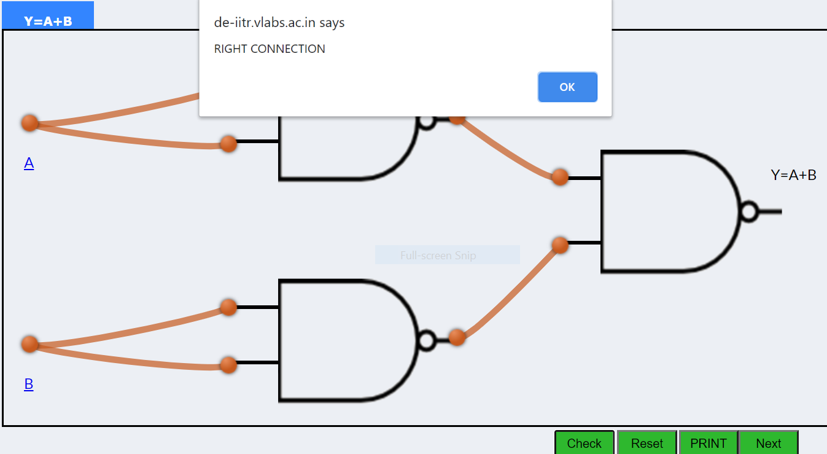

* **NAND Gate as AND Gate**

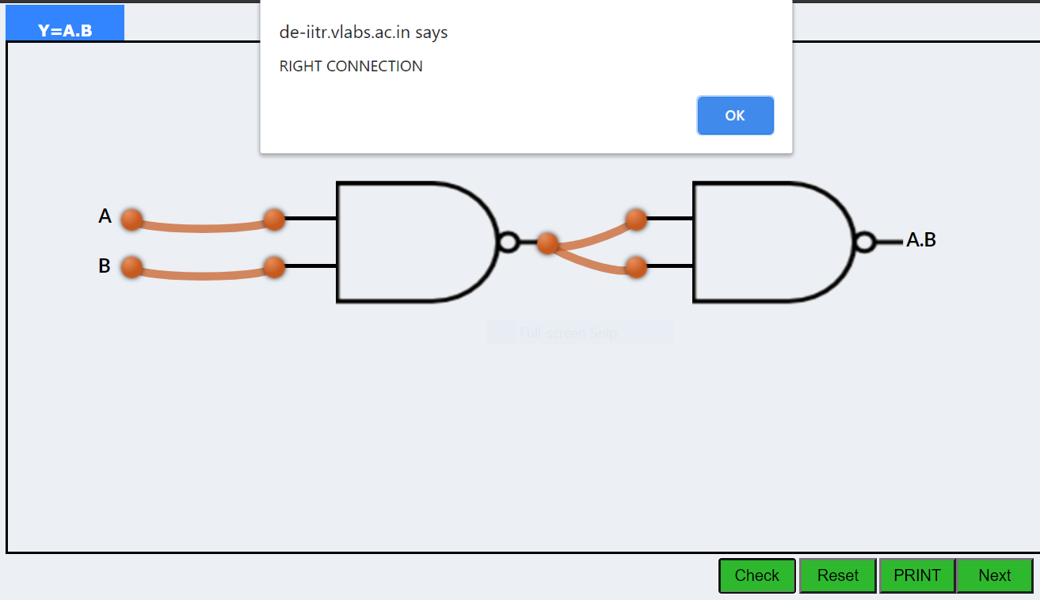

* **NAND Gate as EX-OR Gate**

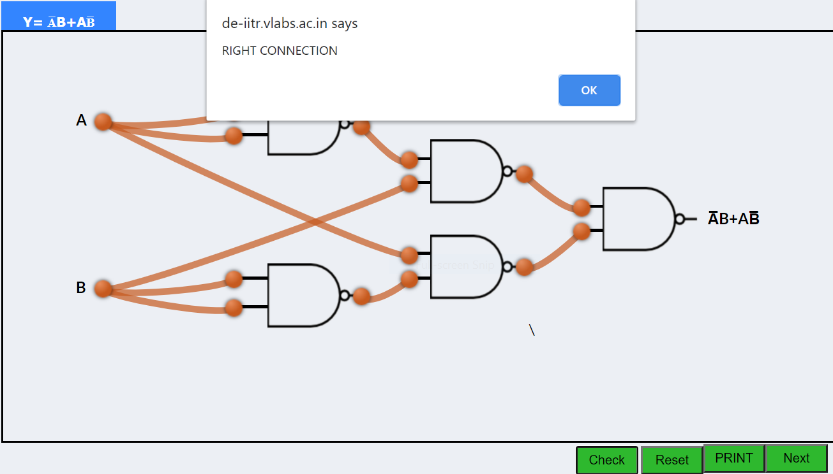

* **NAND Gate as EX-NOR Gate**

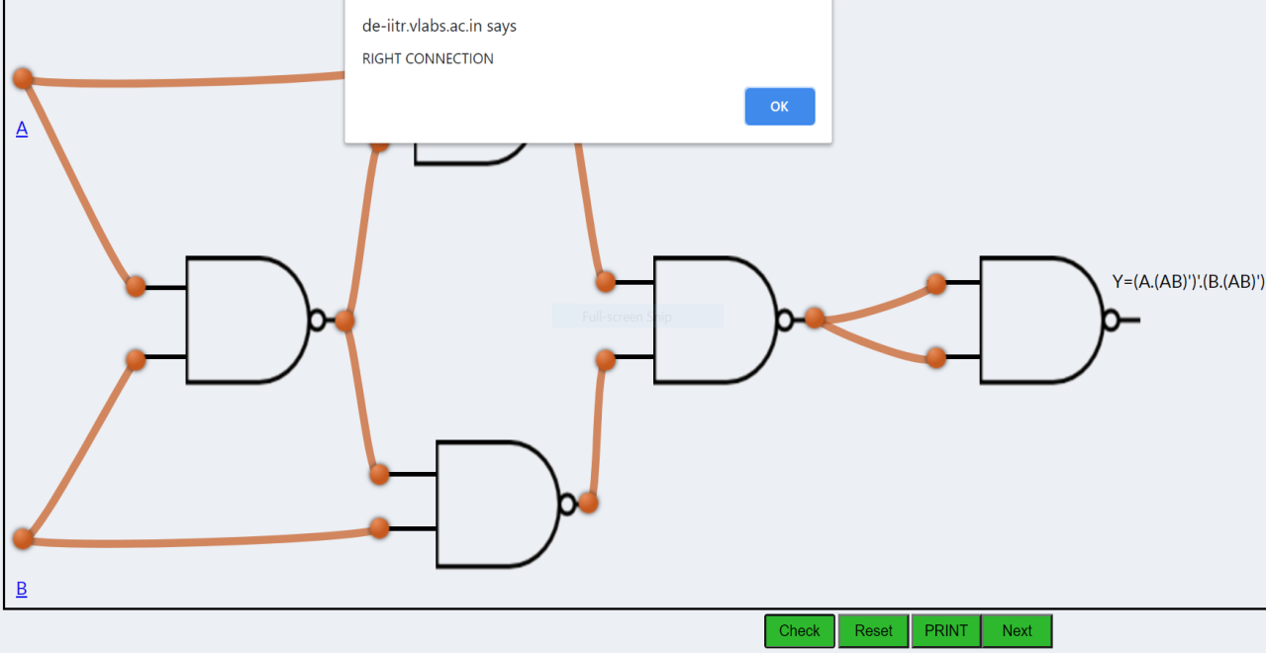

* **Implementing the simplified function with NAND gates only**

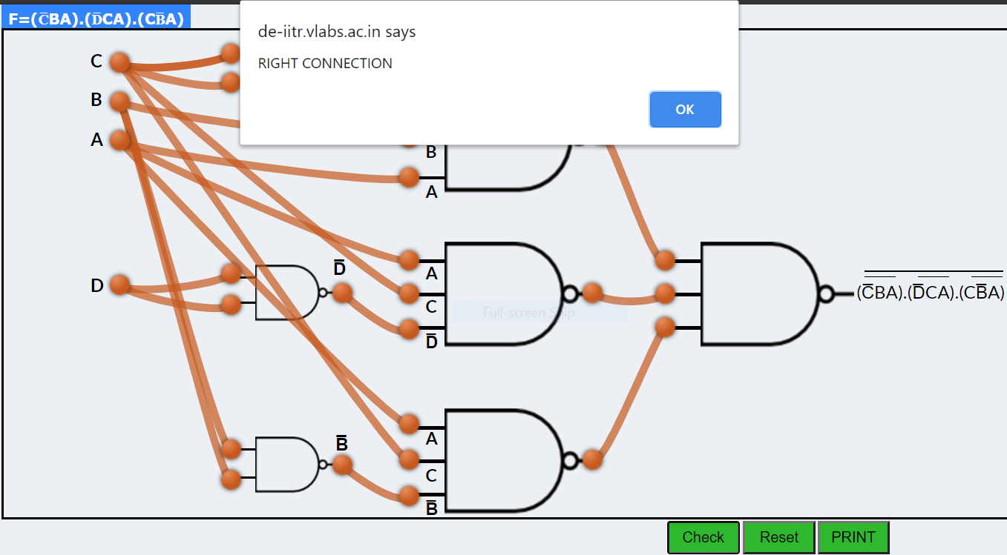

NOR Gate as universal gate:

* **NOR Gate as OR Gate**

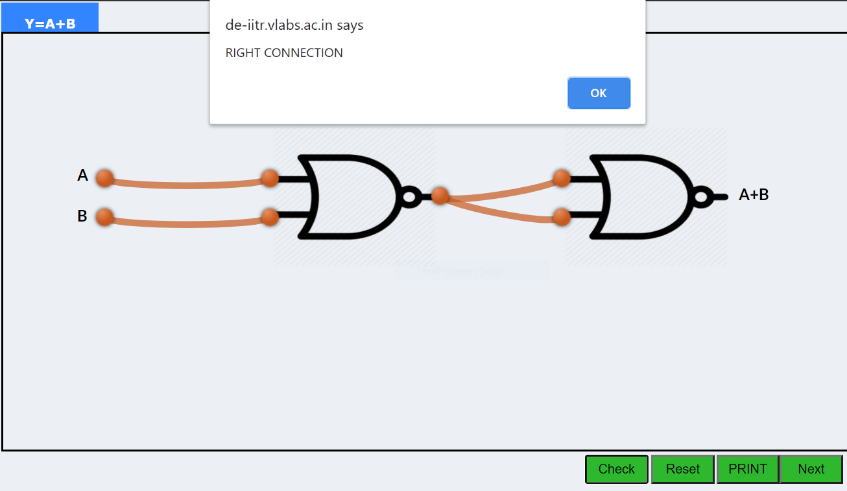

* **NOR Gate as AND Gate**

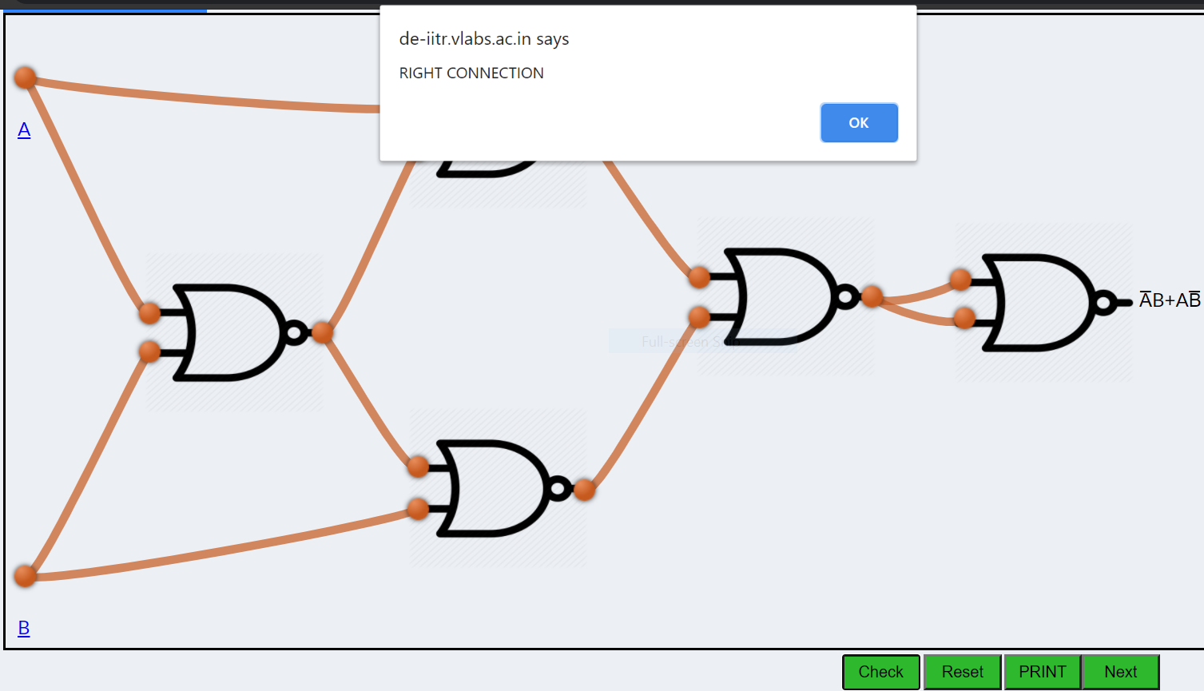

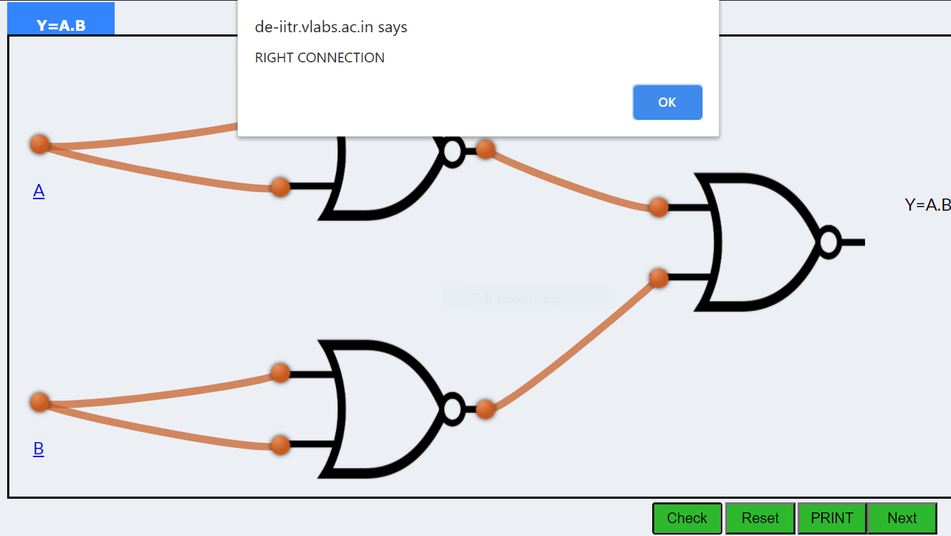

* **NOR Gate as EX-OR Gate**
* **NOR Gate as EX-NOR Gate**

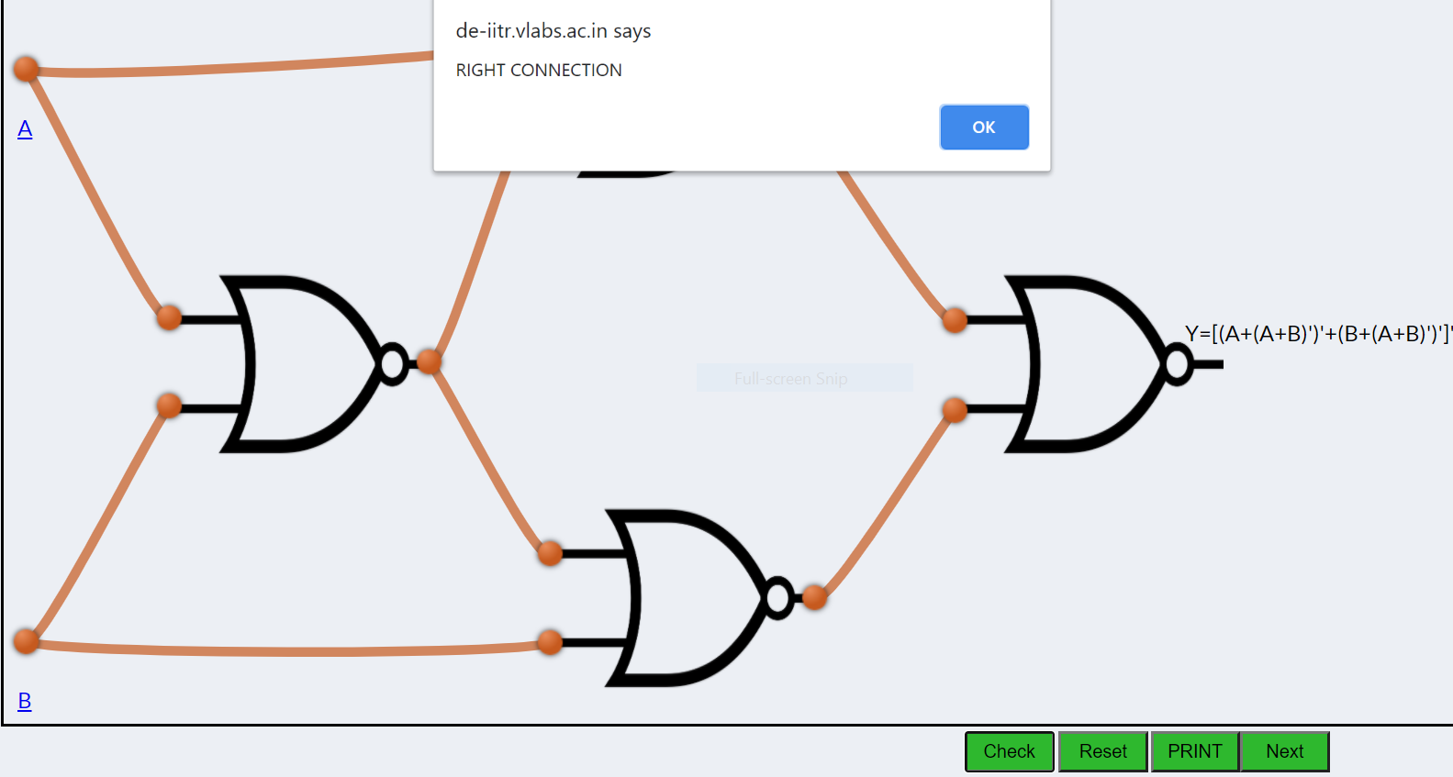

* **Implementing the simplified function with NOR gates only**

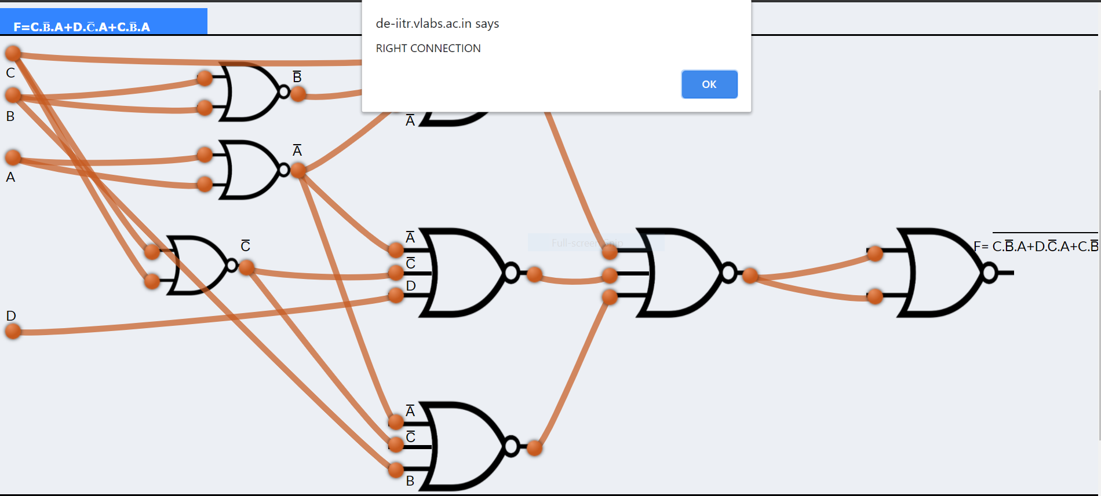

**Conclusion:**

From the above experiment that we perform in the virtual lab we get to learn about the working of universal gates. Also we get to learn how using only the universal gates we can perform all the basic operations that are performed by basic gates.

***********

**Experiment-5**

**Aim:**

To verify the truth table and timing diagram of NOR gate latch using NOR gate IC and analyse the circuit of NOR gate latch with the help of LEDs display.

**Theory:**

Latches are basic storage elements that operate with signal levels (rather than signal transitions). Latches controlled by a clock transition are flip-flops. Latches are level-sensitive devices. Latches are useful for the design of the asynchronous sequential circuit.

SR (Set-Reset) Latch – SR Latch is a circuit with:

(i) 2 cross-coupled NOR gate or 2 cross-coupled NAND gate.

(ii) 2 input S for SET and R for RESET.

(iii) 2 output Q, Q’.

The SR Latch using NOR gate is shown below with its truth table:

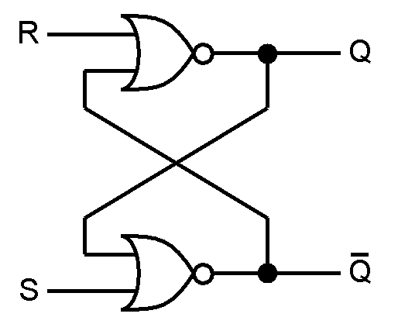 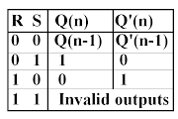

**Figure-1:Logic Symbol of NOR gate latch Figure-2:Truth Table of NOR gate latch**

While the R and S inputs are both low, feedback maintains the Q and Q outputs in a constant state, with Q the complement of Q. If S (Set) is pulsed high while R (Reset) is held low, then the Q output is forced high, and stays high when S returns to low; similarly, if R is pulsed high while S is held low, then the Q output is forced low, and stays low when R returns to low.The R = S = 1 combination is called a restricted combination or a forbidden state because, as both NOR gates then output zeros, it breaks the logical equation Q = Q. The combination is also inappropriate in circuits where both inputs may go low simultaneously (i.e. a transition from restricted to keep). The output would lock at either 1 or 0 depending on the propagation time relations between the gates (a race condition).

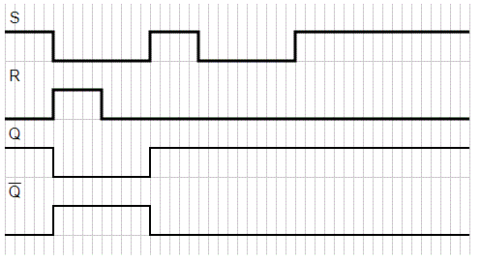

**Figure-3:Timing Diagram of NOR gate latch**

**Procedure:**

Step-1) The supply(+5V)  to the circuit was connected.

Step-2)Switch 1  for input R(Reset) and switch 2  for input S(Set) were pressed.

Step-3) Then the "ADD" button was pressed to add data in the given truth table and simultaneously generated the timing diagram.

Step-4)Step 2 and step 3 for another set of data was repeated.

Step-5) The "Print" button was pressed after completing your simulation to get your results.

**Observation and Result:**

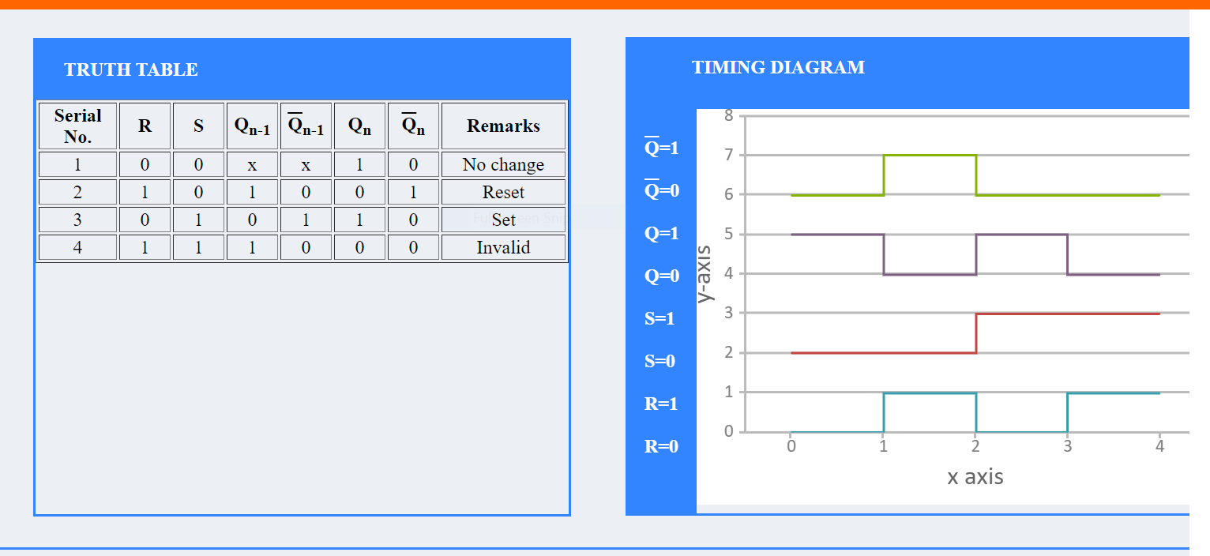

**Conclusion:**

From the above experiment we get to know about latches and and get to learn how we can implement NOR Gate latch using NOR gate IC. And analyzed the result with the help of a truth table and timing diagram.

***********

**Experiment-6**

**Aim:**

To verify the truth table and timing diagram of RS, JK, T and D flip-flops by using NAND & NOR gates ICs and analyse the circuit of RS, JK, T and D flip-flops with the help of LEDs display.

**Theory:**

**Introduction**

A flip flop is an electronic circuit with two stable states that can be used to store binary data. The stored data can be changed by applying varying inputs. Flip-flops and latches are fundamental building blocks of digital electronics systems used in computers, communications, and many other types of systems.

1) R-S flip flop

2) D flip flop

3) J-K flip flop

4) T flip flop

The basic NAND gate RS flip flop circuit is used to store the data and thus provides feedback from both of its outputs again back to its inputs. The RS flip flop actually has three inputs, SET, RESET and its current output Q relating to its current state as shown in figure below.

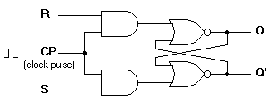

Figure-1:R-S flip flop circuit diagram

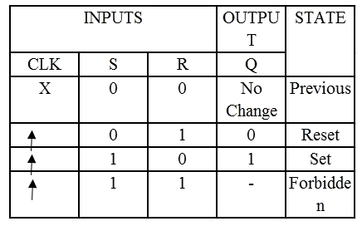

Figure-2:Characteristics table of R-S flip flop

2) D flip flop

A D flip flop has a single data input. This type of flip flop is obtained from the SR flip flop by connecting the R input through an inverter, and the S input is connected directly to data input. The modified clocked SR flip-flop is known as D-flip-flop and is shown below. From the truth table of SR flip-flop we see that the output of the SR flip-flop is in an unpredictable state when the inputs are same and high. In many practical applications, these input conditions are not required. These input conditions can be avoided by making them complement each other.

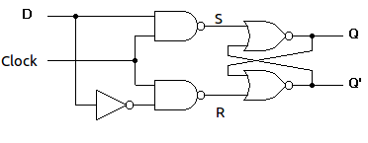

Figure-3:Circuit diagram of D flip flop

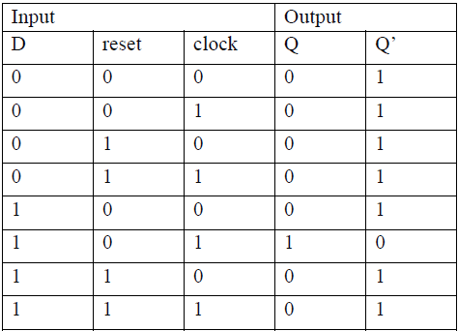

Figure-4:Characteristics table of D flip flop

3) J-K flip flop

In a RS flip-flop the input R=S=1 leads to an indeterminate output. The RS flip-flop circuit may be re-joined if both inputs are 1 than also the outputs are complement of each other as shown in the characteristics table below.

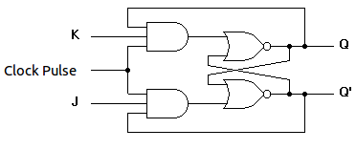

Figure-5:Circuit diagram of J-K flip flop

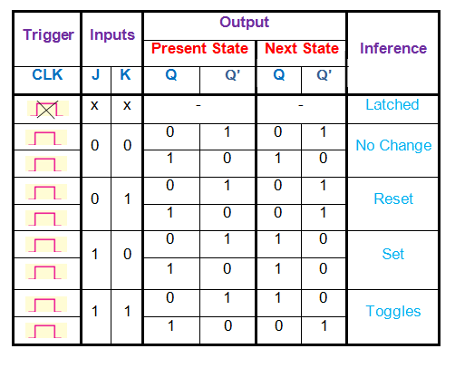

Figure-6:Characteristics table of J-K flip flop

4) T flip flop

T flip-flop is known as toggle flip-flop. The T flip-flop is modification of the J-K flip-flop. Both the JK inputs of the JK flip – flop are held at logic 1 and the clock signal continuous to change as shown in table below.

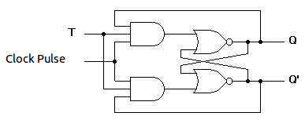

Figure-7:Circuit diagram of T flip flop

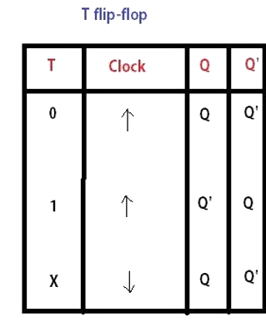

Figure-8:Characteristics table of T flip flop

**Observation and Result:**

1. **R-S flip flop**

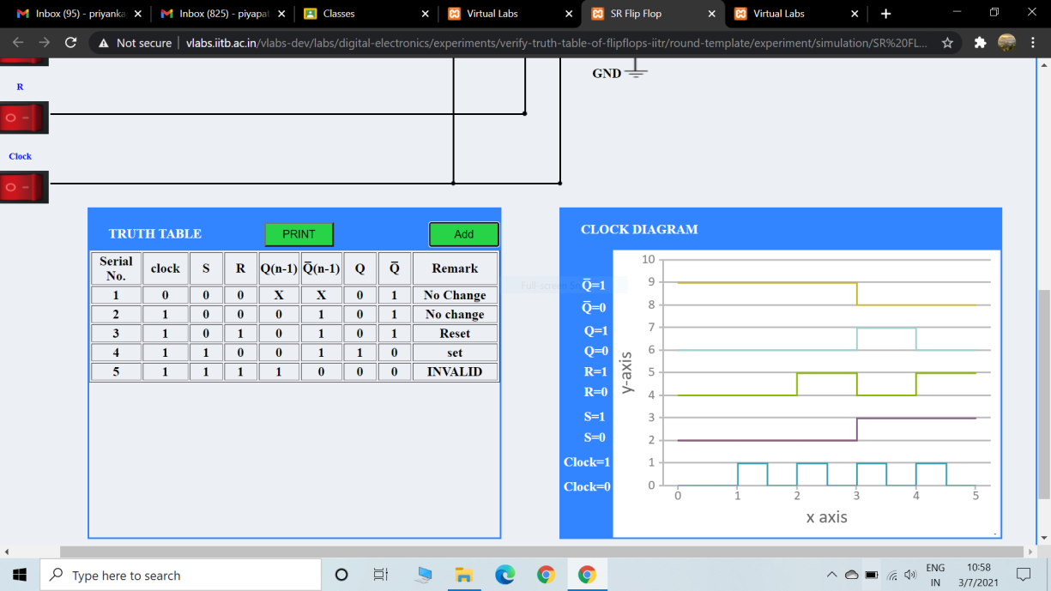

**Conclusion:**

After completion of the above experiment we get the learn the working of various flip flop circuit and to verify the truth table and timing diagram of RS, JK, T and D flip-flops by using NAND & NOR gates ICs and analyse the circuit of RS, JK, T and D flip-flops.

**Experiment-7**

**Aim:**

To analyse the circuit and truth table of 4-bit SIPO (serial input parallel output) shift register by using IC 7474 (D flip flop).

**Theory:**

The operation is as follows. Let's assume that all the flip-flops ( FFA to FFD ) have just been RESET ( CLEAR input ) and that all the outputs QA to QD are at logic level “0” ie, no parallel data output.

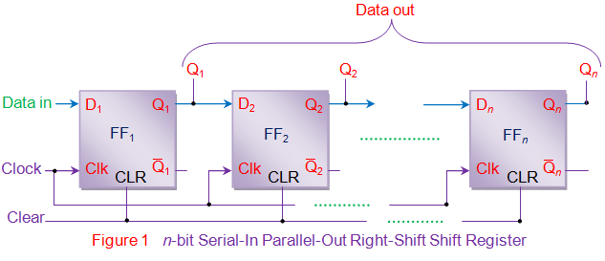

If a logic “1” is connected to the DATA input pin of FFA then on the first clock pulse the output of FFA and therefore the resulting QA will be set HIGH to logic “1” with all the other outputs still remaining LOW at logic “0”. Assume now that the DATA input pin of FFA has returned LOW again to logic “0” giving us one data pulse or 0-1-0. The second clock pulse will change the output of FFA to logic “0” and the output of FFB and QB HIGH to logic “1” as its input D has the logic “1” level on it from QA. The logic “1” has now moved or been “shifted” one place along the register to the right as it is now at QA. When the third clock pulse arrives this logic “1” value moves to the output of FFC ( QC ) and so on until the arrival of the fifth clock pulse which sets all the outputs QA to QD back again to logic level “0” because the input to FFA has remained constant at logic level “0”. The effect of each clock pulse is to shift the data contents of each stage one place to the right, and this is shown in the following table until the complete data value of 0-0-0-1 is stored in the register. This data value can now be read directly from the outputs of QA to QD.Then the data has been converted from a serial data input signal to a parallel data output. The truth table and following waveforms show the propagation of the logic “1” through the register from left to right as follows.

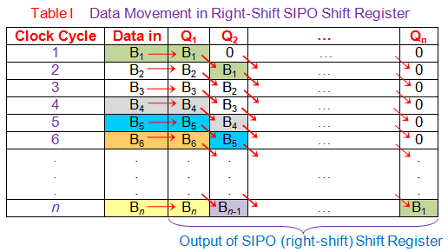

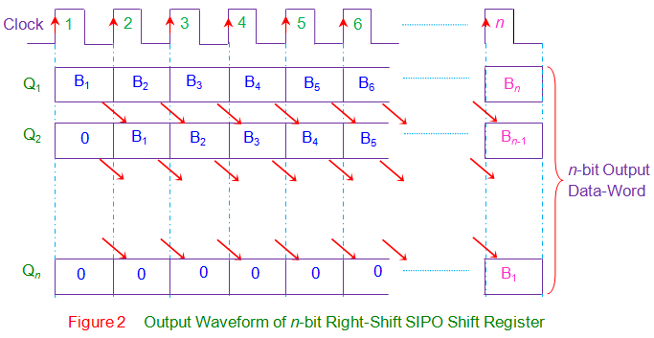

Note that after the fourth clock pulse has ended the 4-bits of data ( 0-0-0-1 ) are stored in the register and will remain there provided clocking of the register has stopped. In practice the input data to the register may consist of various combinations of logic “1” and “0”. Commonly available SIPO IC’s include the standard 8-bit 74LS164 or the 74LS594.In the right-shift SIPO shift-register, data bits shift from left to right for each clock pulse. However if the data bits are made to shift from right to left in the same design, one gets a left-shift SIPO shift-register as shown by figure 3. Nevertheless the basic working principle remains the same except the fact that now Bn down to B1 is stored in Qn down to Q1 i.e. Q1 = B1, Q2 = B2 … Qn = Bn at the nth clock pulse.

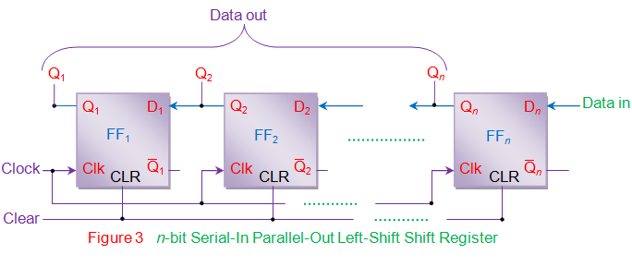

**Procedure:**

Step-1) The supply(+5V) to the circuit was connected.

Step-2) The Reset and Preset as active-high signals were kept .

Step-3) The data at data input was kept .

Step-4) Clock pulse was pressed and observed this data at LED Q3 .

Step-5) Then the "ADD" button to add data in the given truth table was pressed.

Step-6) The next data at data input was applied.

Step-7) Clock pulse was pressed and observed that the data at LED Q3will shift to LED Q2 and the new data applied would appear at Q3 .

Step-8)Steps 3 to 5 till all the 4 bits appear at the output of the shift register was repeated. Step-9) The "Print" button after completing simulation to get results was pressed.

**Observation and Result:**

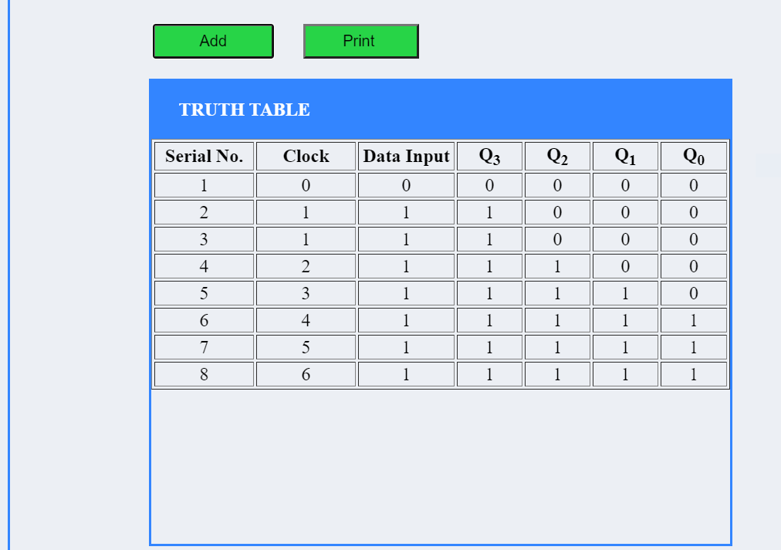

**Conclusion:**

From the above experiment we get to know about latches and and get to analyse the circuit and truth table of 4-bit SIPO (serial input parallel output) shift register by using IC 7474 (D flip flop).

**Experiment-8**

**Aim:**

#### To analyse the truth table of 4 * 2 decoder/de-multiplexer using NOT (7404) and AND (7408) logic gate ICs and 2 * 4 encoder using OR (7403) logic gate IC and to understand the working of 4 * 2 decoder and 2 * 4 encoder circuit with the help of LEDs display.

**Theory:**

Binary code of N digits can be used to store 2N distinct elements of coded information. This is what encoders and decoders are used for. Encoders convert 2N lines of input into a code of N bits and Decoders decode the N bits into 2N lines.

### **1) 2x4 Decoder / Demultiplexer**

A **1**-to-2 **demultiplexer** consists of **one** input line, two output lines and **one** select line. The signal on the select line helps to switch the input to **one** of the two outputs. The figure below shows the block diagram of a **1**-to-2 **demultiplexer** with additional enable input.

#### **1.1) 2-to-4 Binary Decoder**

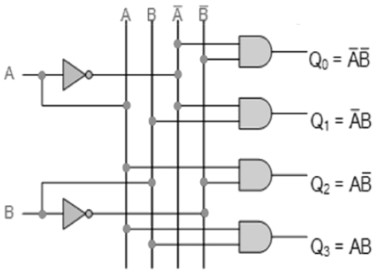

**Figure 2. Circuit Diagram of 2-to-4 Decoder**

The 2-to-4 line binary decoder depicted above consists of an array of four AND gates. The 2 binary inputs labelled A and B are decoded into one of 4 outputs, hence the description of 2-to-4 binary decoder. Each output represents one of the minterms of the 2 input variables, (each output = a minterm).

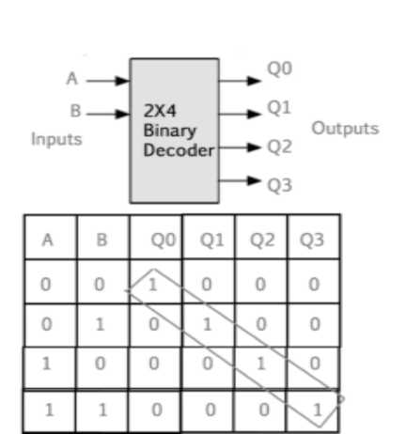

**Figure 3. Logic Diagram and Truth table of 2-to-4 Decoder**

The binary inputs A and B determine which output line from Q0 to Q3 is “HIGH” at logic level “1” while the remaining outputs are held “LOW” at logic “0” so only one output can be active (HIGH) at any one time.

Therefore, whichever output line is “HIGH” identifies the binary code present at the input, in other words it “decodes” the binary input.Some binary decoders have an additional input pin labelled “Enable” that controls the outputs from the device.

This extra input allows the decoders outputs to be turned “ON” or “OFF” as required. Output is only generated when the Enable input has value 1; otherwise, all outputs are 0. Only a small change in the implementation is required: the Enable input is fed into the AND gates which produce the outputs.

If Enable is 0, all AND gates are supplied with one of the inputs as 0 and hence no output is produced. When Enable is 1, the AND gates get one of the inputs as 1, and now the output depends upon the remaining inputs. Hence the output of the decoder is dependent on whether the Enable is high or low.

### 

### **2) Encoder**

An Encoder is a combinational circuit that performs the reverse operation of Decoder.It has a maximum of 2n input lines and ‘n’ output lines, hence it encodes the information from 2n inputs into an n-bit code. It will produce a binary code equivalent to the input, which is active High. Therefore, the encoder encodes 2n input lines with ‘n’ bits.

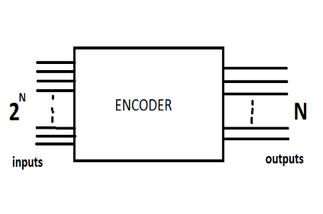

**Figure 4. Logic Diagram of ENCODER**

#### **2.1 )4 : 2 Encoder**

The 4 to 2 Encoder consists of four inputs Y3, Y2, Y1 & Y0 and two outputs A1 & A0. At any time, only one of these 4 inputs can be ‘1’ in order to get the respective binary code at the output.

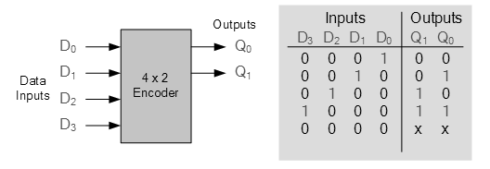

**Figure 5. Logic symbol and truth table of 4 to 2 encoder**

**Procedure:**

### **1)2X4 DECODER / Demultiplexer**

Step-1) The supply(+5V)  to the circuit was connected.

Step-2) First the "ADD" button to add the basic state of your output in the given table was pressed.

Step-3) he switches to select the required inputs named "A" and "B" was pressed. Also their corresponding outputs named "Q0" and "Q1" and "Q2" and "Q3" were checked.

Step-4) "ADD" button to add your inputs and outputs in the given table was pressed.

Step-5) Step 3 & step 4 for the next state of inputs and their corresponding outputs was pressed.

Step-6) The "PRINT" button after completing your simulation to get your results was pressed.

### **2)4X2 ENCODER**

Step-1) The supply(+5V)  to the circuit was connected.

Step-2) First the "ADD" button to add the basic state of your output in the given table was pressed.

Step-3) The switches to select the required inputs "D0" and "D1" and "D2" and "D3"were pressed. Also their corresponding outputs named "Q1" and "Q0" were checked.

Step-4) "ADD" button to add your inputs and outputs in the given table was pressed.

Step-5) Step 3 & step 4 for the next state of inputs and their corresponding outputs was repeated.

Step-6) The "PRINT" button after completing your simulation to get your results was pressed.

**Observation and Result:**

Decoder

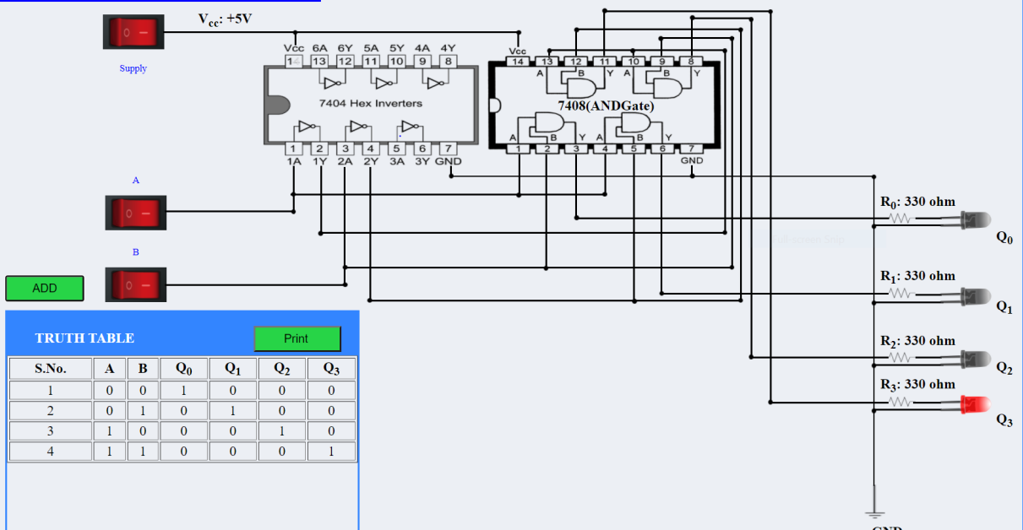

Encoder

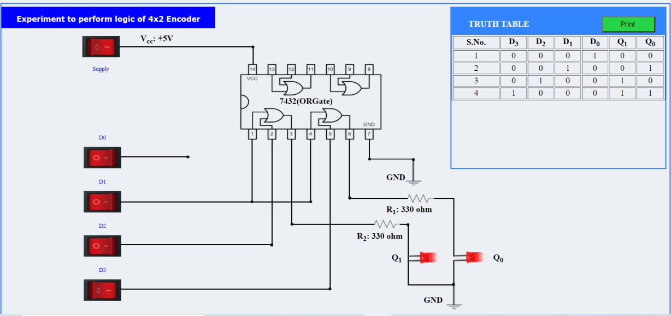

**Conclusion:**

From the above experiment we get to know about latches and and get To analyse the truth table of 4 * 2 decoder/de-multiplexer using NOT (7404) and AND (7408) logic gate ICs and 2 * 4 encoder using OR (7403) logic gate IC and to understand the working of 4 * 2 decoder and 2 * 4 encoder circuit with the help of LEDs display.

***********

**Experiment-9**

**Aim:**

#### To analyse the truth table and working of 1x4 De-Multiplexer by using 3-input NAND and 1-input NOT logic gate ICs and 4x1 Multiplexer by using 3-input AND, 3-input OR, and 1-input NOT logic gate ICs.

**Theory:**

The function of a multiplexer is to select the input of any ‘n’ input lines and feed that to one output line. The function of a demultiplexer is to inverse the function of the multiplexer and the shortcut forms of the multiplexer. The de-multiplexers are mux and demux. Some multiplexers perform both multiplexing and demultiplexing operations.

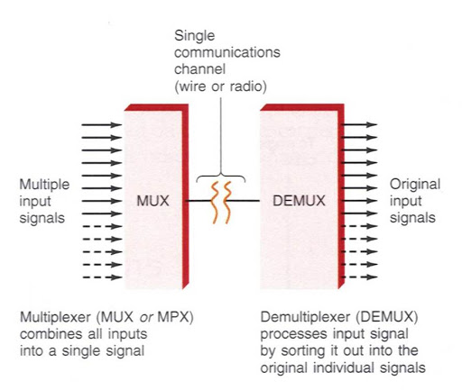

Fig:-Block Diagram of Multiplexer and Demultiplexer

### 

### **1) Multiplexer**

Multiplexer is a device that has multiple inputs and a single line output. The select lines determine which input is connected to the output, and also to increase the amount of data that can be sent over a network within a certain time. It is also called a data selector.It has a maximum of 2n data inputs, ‘n’ selection lines and single output line. One of these data inputs will be connected to the output based on the values of selection lines.

Since there are ‘n’ selection lines, there will be 2n possible combinations of zeros and ones. So, each combination will select only one data input. Multiplexer is also called a Mux.

Multiplexers are classified into four types:

a) 2-1 multiplexer (1 select line)

b) 4-1 multiplexer (2 select lines)

c) 8-1 multiplexer(3 select lines)

d) 16-1 multiplexer (4 select lines)

1.1) 4x1 Multiplexer

4x1 Multiplexer has four data inputs D0, D1, D2 & D3, two selection lines S0 & S1 and one output Y. The block diagram of 4x1 Multiplexer is shown in the following figure.One of these 4 inputs will be connected to the output based on the combination of inputs present at these two selection lines. Truth table of 4x1 Multiplexer is shown below.

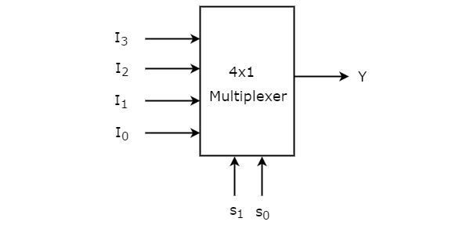

**Figure-2:Block diagram of 4x1 Multiplexer**

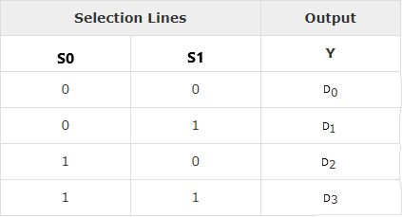

**Figure-3:Truth table of 4x1 Multiplexer**

From Truth table, we can directly write the Boolean function for output, Y as

**Y=S1′S0′I0+S1′S0I1+S1S0′I2+S1S0I3**

We can implement this Boolean function using Inverters, AND gates & OR gate. The circuit diagram of 4x1 multiplexer is shown in the following figure.

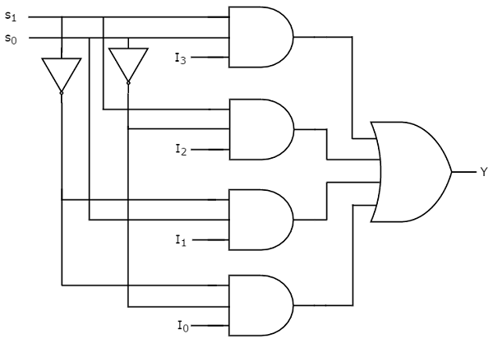

We can easily understand the operation of the above circuit. Similarly, you can implement 8x1 Multiplexer and 16x1 multiplexer by following the same procedure.

**2) Demultiplexer**

De-multiplexer is also a device with one input and multiple output lines. It is used to send a signal to one of the many devices. The main difference between a multiplexer and a demultiplexer is that a multiplexer takes two or more signals and encodes them on a wire, whereas a demultiplexer does reverse to what the multiplexer does.

Demultiplexer are classified into four types:

a)1-2 demultiplexer (1 select line)

b)1-4 demultiplexer (2 select lines)

c)1-8 demultiplexer (3 select lines)

d)1-16 demultiplexer (4 select lines)

**2.2) 1x4 Demultiplexer**

1x4 Demultiplexer has one input Data(D), two selection lines, S0 & S1 and four outputs Y0, Y1, Y2 & Y3. The block diagram of 1x4 Demultiplexer is shown in the following figure.

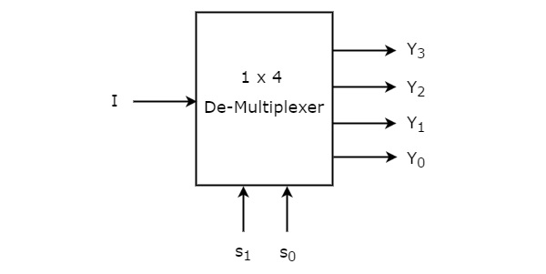

**Figure-4:Block diagram of 1x4 De-Multiplexer**

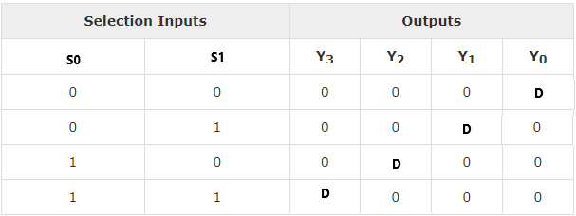

**Figure-5:Truth table of 1x4 De-Multiplexer**

From the above Truth table, we can directly write the Boolean functions for each output as

**Y3=s1s0I**

**Y2=s1s0′I**

**Y1=s1′s0I**

**Y0=s1′s0′I**

We can implement these Boolean functions using Inverters & 3-input AND gates. The circuit diagram of 1x4 De-Multiplexer is shown in the following figure.

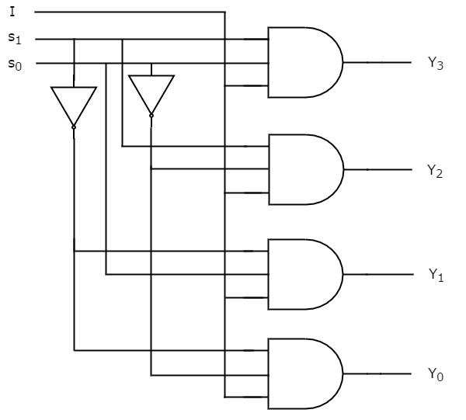

We can easily understand the operation of the above circuit. Similarly, you can implement 1x8 De-Multiplexer and 1x16 De-Multiplexer by following the same procedure.

**Procedure:**

**1) 4x1 Multiplexer**

Step-1) Supply(+5V)  to the circuit was connected.

Step-2) "ADD" button to add basic state of your output in the given table was pressed firstly.

Step-3) Switches "S0" and "S1"to select the desired input line was pressed.

Step-4) "D0"/"D1"/"D2"/"D3" any one button to add your inputs was pressed.

Step-5) "ADD" button to add your inputs and outputs in the given table was pressed.

Step-6) Step 3, 4 and step 5 for next state of inputs and their corresponding outputs were repeated.

Step-7) The "PRINT" button after completing your simulation to get your results was pressed.

**2) 1x4 De-Multiplexer**

Step-1)The supply(+5V)  to the circuit was connected.

Step-2)"ADD" button to add basic state of your output in the given table was pressed.

Step-3) The switch Data(D) for Input was pressed.

Step-4) Switches "S0" and "S1" to select the desired input line were pressed.

Step-5)"ADD" button to add your inputs and outputs in the given table was pressed.

Step-6) Step 4 and step 5 for next state of inputs and their corresponding outputs were repeated.

Step-7) The "PRINT" button after completing your simulation to get your results was pressed.

**Observation and Result:**

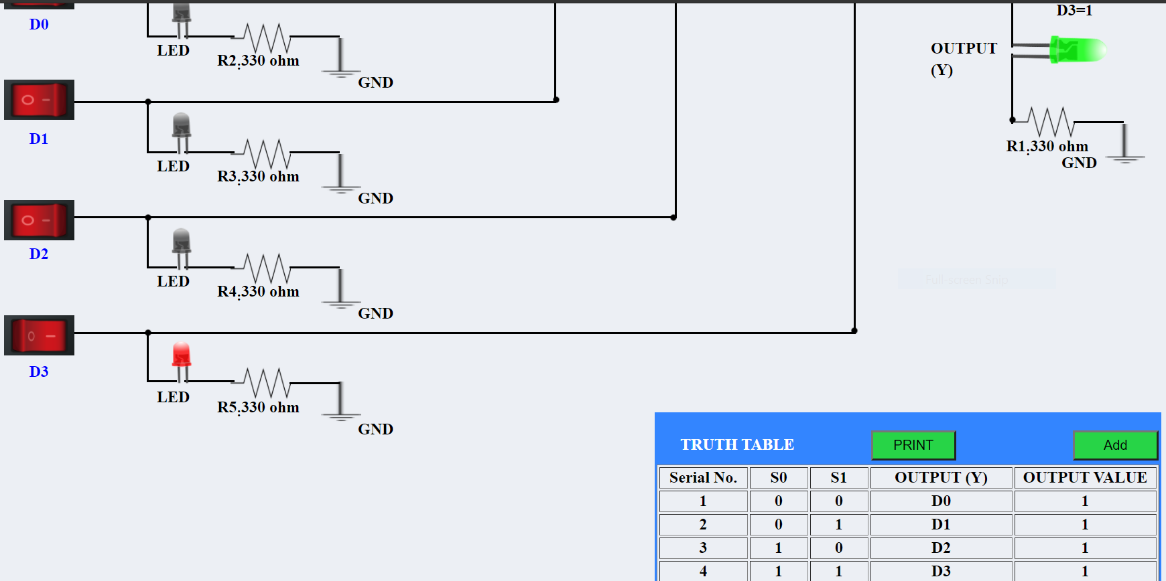

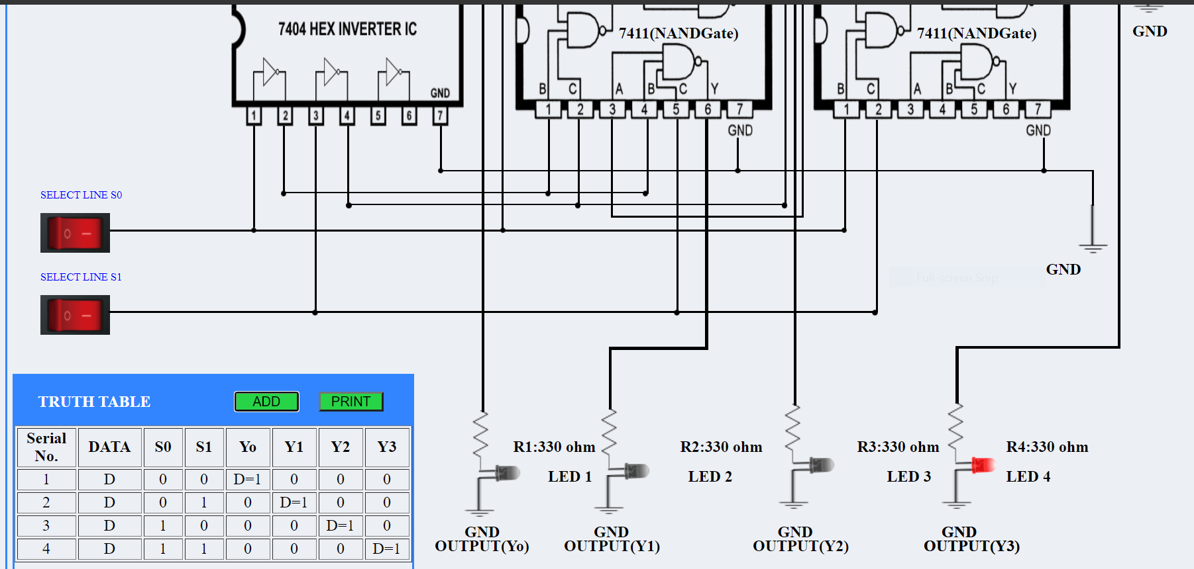

**Conclusion:**

From the above experiment we get to know about the working of multiplexer and de-multiplexer.

And also successfully found out the truth table of 4X1 Mux and 1X4 De-mux.

***********

**Experiment-10**

**Aim:**

#### To verify the truth table and timing diagram of 4-bit synchronous parallel counter and 4-bit asynchronous parallel counter by using JK flip flop ICs and analyse the circuit of 4-bit synchronous parallel counter and 4-bit asynchronous parallel counter with the help of LEDs display.

#### **Theory:**

#### A counter is a device which stores (and sometimes displays) the number of times a particular event or process has occurred, often in relationship to a clock signal. Counters are used in digital electronics for counting purposes, they can count specific events happening in the circuit. For example, in UP counter a counter increases count for every rising edge of clock.

### **Classification of Counters**

Counters are broadly divided into two categories

1. Asynchronous counter
2. Synchronous counter

**Asynchronous counter:**

In asynchronous counters we don’t use universal clock, only the first flip flop is driven by the main clock and the clock input of the rest of the following counters is driven by output of previous flip flops. We can understand it by following diagram:-

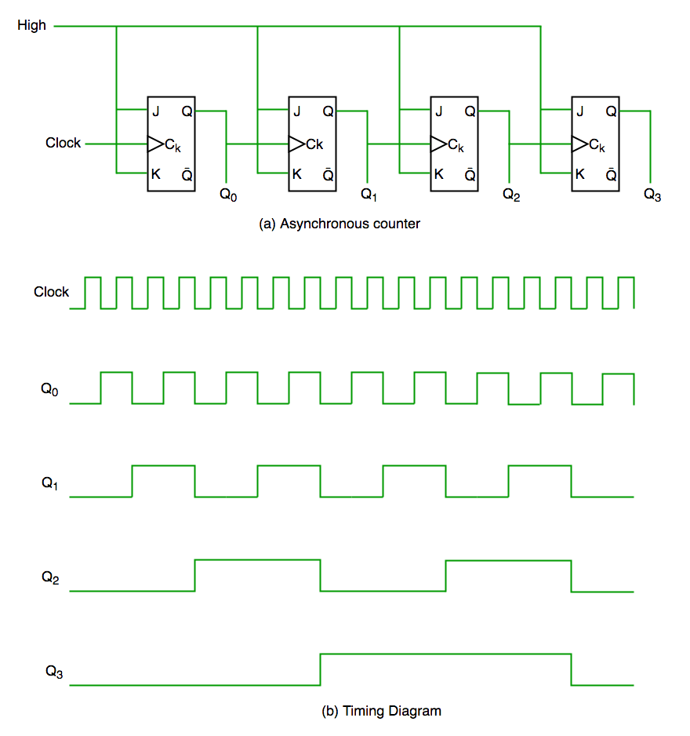

Figure-1: Asynchronous Counter Circuit and Timing Diagram

It is evident from the timing diagram that Q0 is changing as soon as the rising edge of the clock pulse is encountered, Q1 is changing when the rising edge of Q0 is encountered(because Q0 is like clock pulse for second flip flop) and so on. In this way ripples are generated through Q0,Q1,Q2,Q3 hence it is also called RIPPLE counter.

**Synchronous Counter**

Unlike the asynchronous counter, synchronous counter has one global clock which drives each flip flop so output changes in parallel. The one advantage of synchronous counter over asynchronous counter is, it can operate on higher frequency than asynchronous counter as it does not have cumulative delay because the same clock is given to each flip flop.

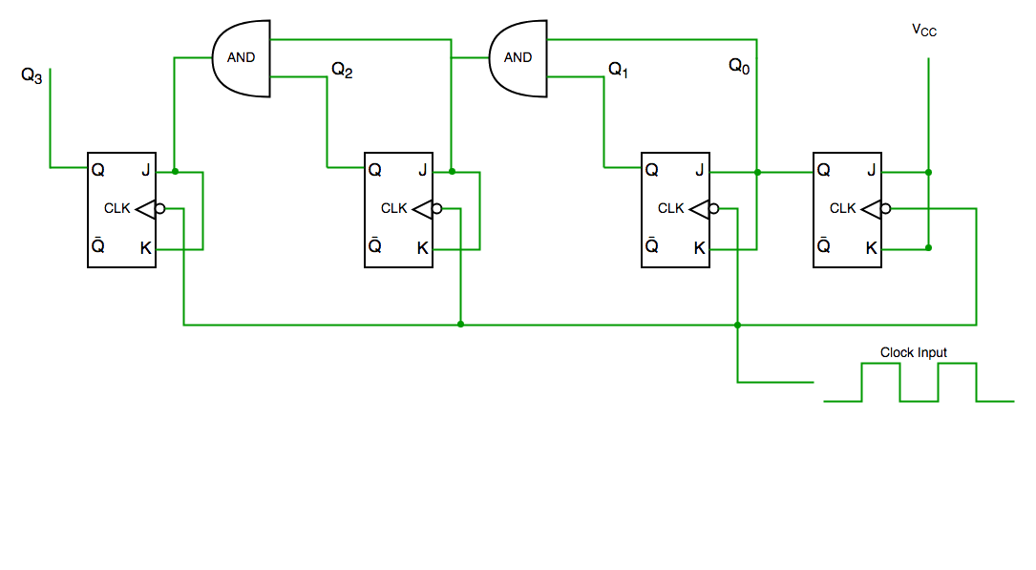

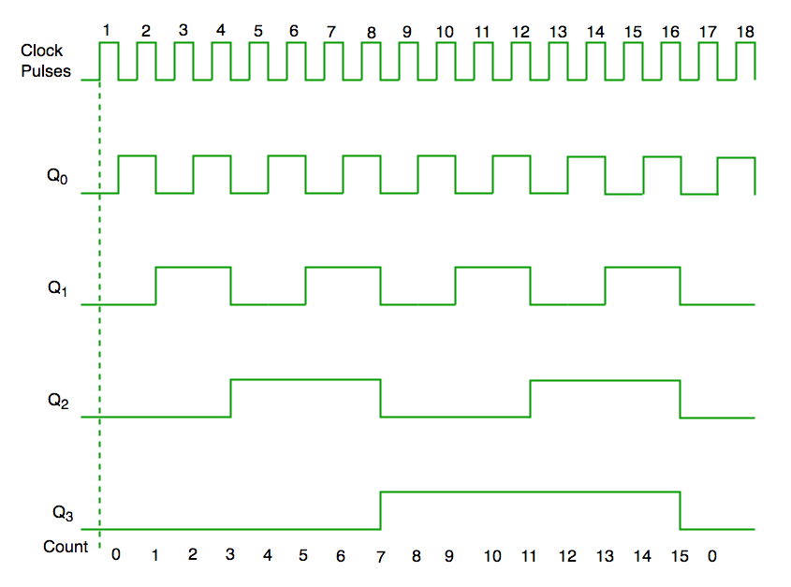

Figure-2: Synchronous Counter Circuit and Timing Diagram

From the circuit diagram we see that Q0 bit gives response to each falling edge of clock while Q1 is dependent on Q0, Q2 is dependent on Q1 and Q0 , Q3 is dependent on Q2,Q1 and Q0.

**Procedure:**

**Synchronous Counter**

Step-1)Switch to supply 5V to the circuit was pressed.

The switch in ON state is  and the switch in OFF state is 

Step-2)Counter button to start the counter was pressed.

Step-3) Different combinations of LEDs were lit up for different combinations of inputs.

The LED in OFF state was 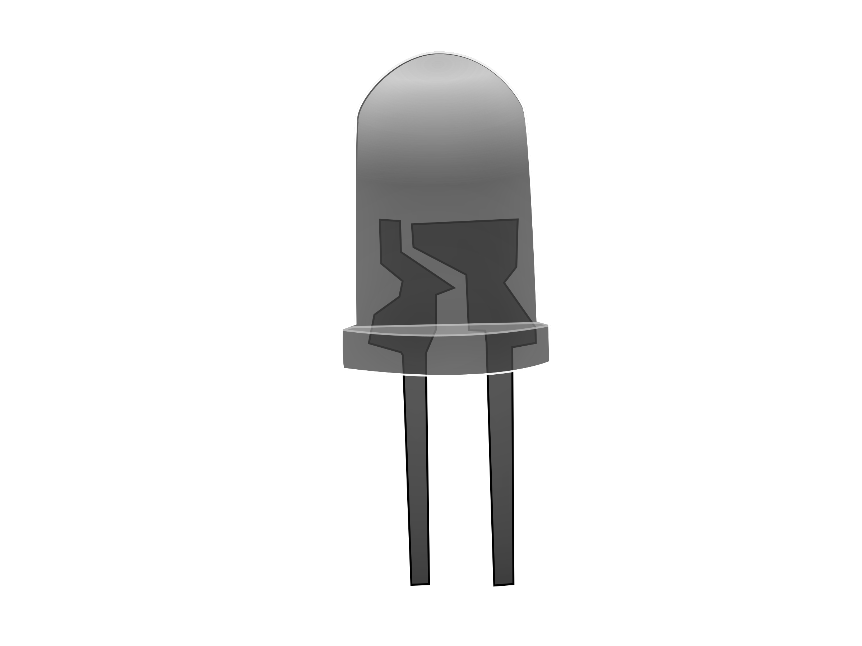 and the LED in ON state was  .

The data was simultaneously added to the Truth Table.

Step-4)Steps 2 to 3 were repeated for another set of data.

Step-5)"Generate Waveform" Button to generate the Timing Diagram was generated .

Step-6)"Print" to get the print out of the Truth Table and the Timing Diagram was clicked.

**Asynchronous Counter**

Step-1)Switch to supply 5V to the circuit was pressed.

The switch in ON state was  and the switch in OFF state was 

Step-2)Counter button to start the counter was pressed.

Step-3) Different combinations of LEDs were lit up for different combinations of inputs.

The LED in OFF state was and the LED in ON state was  .

The data was simultaneously added to the Truth Table.

Step-4)Steps 2 to 3 for another set of data were repeated.

Step-5)"Generate Waveform" Button to generate the Timing Diagram was pressed .

Step-6)"Print" to get the print out of the Truth Table and the Timing Diagram were pressed.

**Output & Result:**

**Asynchronous:**

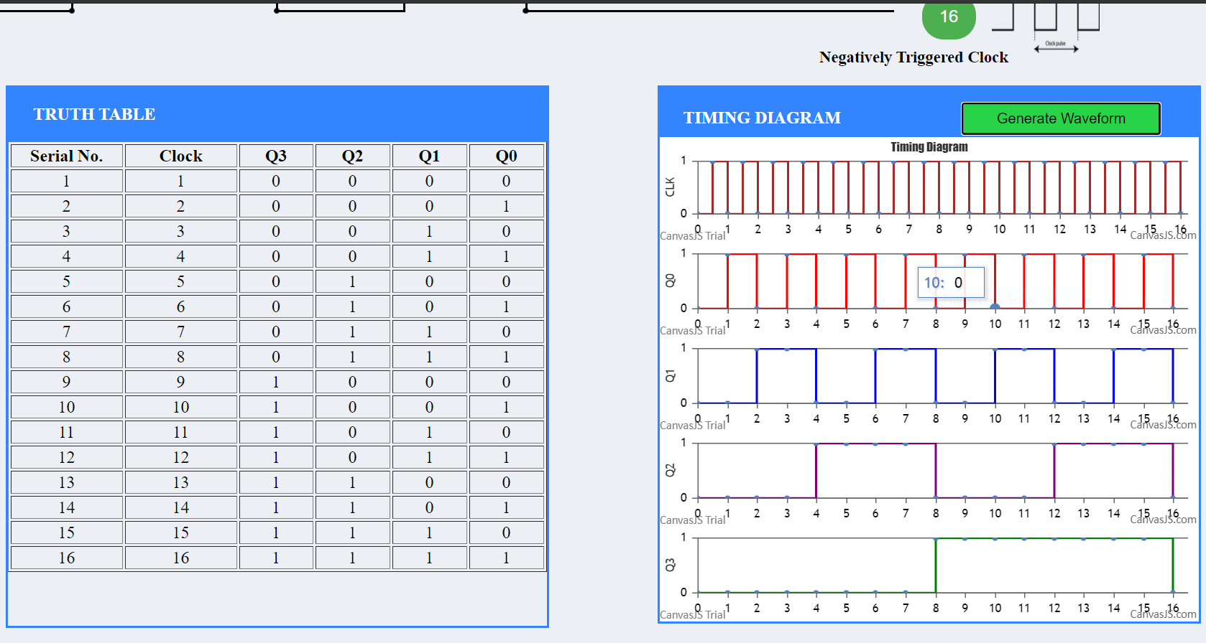

**Synchronous:**

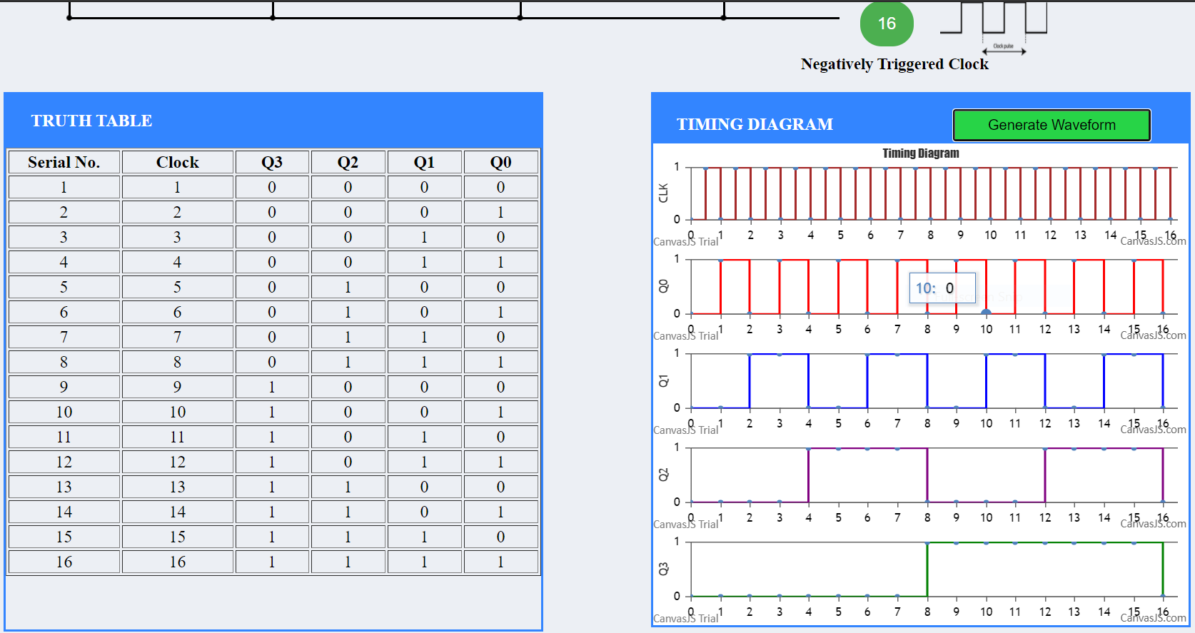

**Conclusion:**

From the above experiment we get to know about asynchronous and synchronous parallel counter and also learn to verify the truth table and timing diagram of 4-bit synchronous parallel counter and 4-bit asynchronous parallel counter by using JK flip flop ICs and analyse the circuit of 4-bit synchronous parallel counter and 4-bit asynchronous parallel counter with the help of LEDs display.

***********

**Experiment-11**

**Aim:**

To analyse the truth table of binary to gray and gray to binary converter using a combination of NAND gates and to understand the working of binary to gray and gray to binary converter with the help of LEDs display.

**Theory:**

**Introduction:**

A binary number system is one of the four types of number system. In computer applications, where binary numbers are represented by only two symbols or digits, i.e. 0 (zero) and 1(one). The binary numbers here are expressed in the base-2 numeral system.

Gray code has the property that two successive numbers differ in only one bit because of this property gray code does the cycling through various states with minimal effort and used in K-maps, error correction, communication etc.

In computer science many a times we need to convert binary code to gray code and vice versa. This conversion can be done by applying following rules :

**Binary to Gray Conversion:**

Gray codes are used in rotary and optical encoders, Karnaugh maps, and error detection. The hamming distance of two neighbours Gray codes is always 1 and also first Gray code and last Gray code also has Hamming distance is always 1, so it is also called *Cyclic codes*.

The Binary to Gray code converter is a logical circuit that is used to convert the binary code into its equivalent Gray code. By putting the MSB of 1 below the axis and the MSB of 1 above the axis and reflecting the (n-1) bit code about an axis after 2n-1 rows, we can obtain the n-bit gray code.

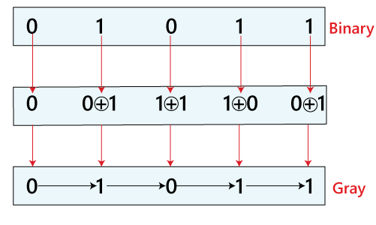

The 4-bit binary to gray code conversion table is as follows:

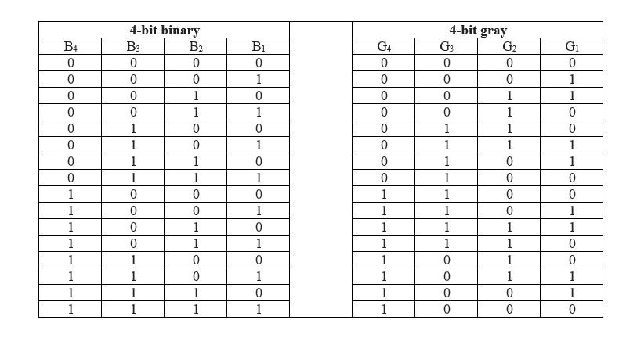

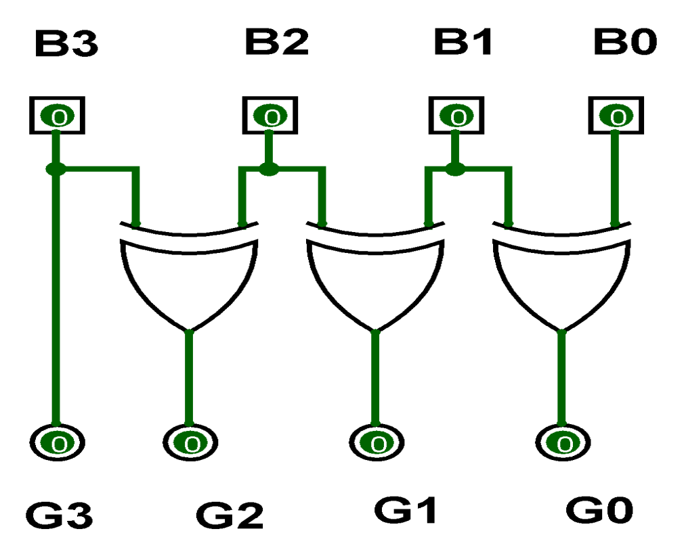

**Logic Diagram of Binary to Gray**

**Gray to binary conversion:**

The Gray to Binary code converter is a logical circuit that is used to convert the gray code into its equivalent binary code. There is the following circuit used to convert the Gray code to binary number.

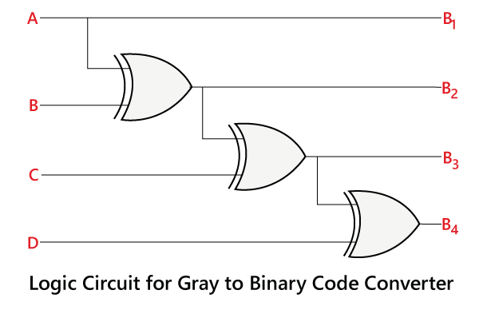

Just like Binary to Gray code conversion; it is also a very simple process. There are the following steps used to convert the Gray code into binary.

* Just like binary to gray, in gray to binary, the 1st bit of the binary number is similar to the MSB of the Gray code.
* The 2nd bit of the binary number is the same as the 1st bit of the binary number when the 2nd bit of the Gray code is 0; otherwise, the 2nd bit is altered bit of the 1st bit of binary number. It means if the 1st bit of the binary is 1, then the 2nd bit is 0, and if it is 0, then the 2nd bit be 1.
* The 2nd step continues for all the bits of the binary number.

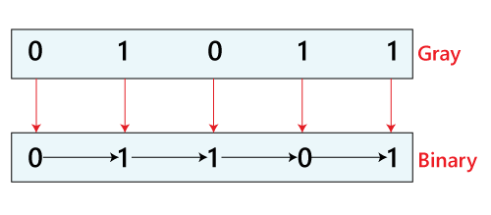

The bits of 4-bit Gray code are considered as G4G3G2G1. Now from the conversion table,

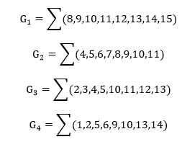

The [Karnaugh maps](https://www.electrical4u.com/k-map/) (K-maps) for G4, G3, G2, and G1 are as follows:

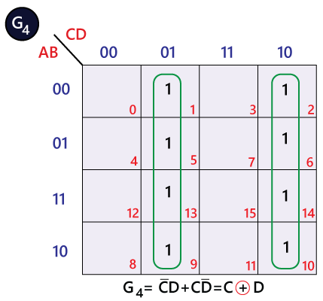 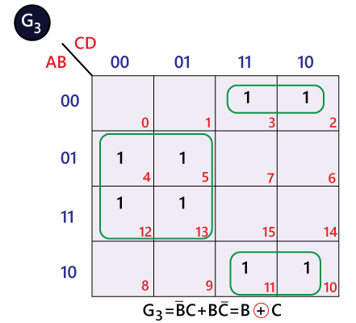

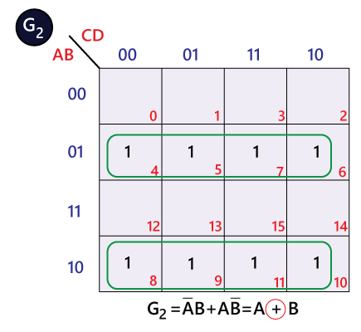 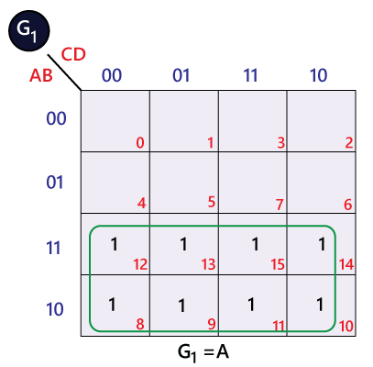

**Procedure:**

**Binary to Gray Code Conversion**

Step-1) Battery to supply 5V was connected to the circuit.

Step-2)Switches for different inputs were pressed.

The switch in ON state is  and the switch in OFF state is 

Step-3) The corresponding combination of input and output LEDs were lit up for different combinations of inputs.

The input binary code LEDs were B3,B2,B1 and B0 and the output gray code LEDs G3,G2,G1 and G0 glow accordingly.

The input LED in OFF state is  and in ON state is  .

The output LED in OFF state is 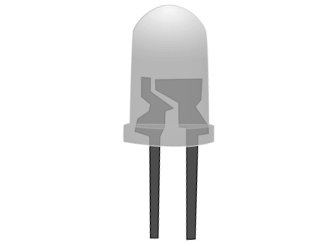 and in ON state is 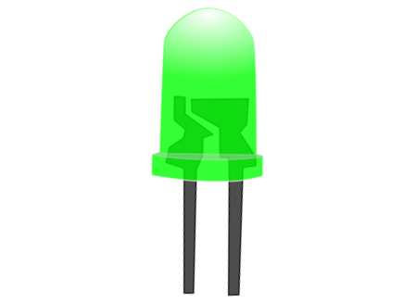 .

Step-4) "Add" was clicked to add the values to the Truth Table.

Step-5) "Print" was to get the print out of the Truth Table.

**Gray to Binary Conversion**

Step-1) Battery was connected to supply 5V to the circuit.

Step-2)Switches were pressed for different inputs.

The switch in ON state is  and the switch in OFF state is 

Step-3) The corresponding combination of input and output LEDs were lit up for different combinations of inputs.

The input gray code LEDs are G3,G2,G1 and G0 and the output binary code LEDs B3,B2,B1 and B0 glow accordingly.

The input LED in OFF state is  and in ON state is  .

The output LED in OFF state is  and in ON state is  .

Step-4) "Add"was clicked to add the values to the Truth Table.

Step-5) "Print" was clicked to get the print out of the Truth Table.

**Output & Result:**

**Binary To Gray conversion:**

Truth table:

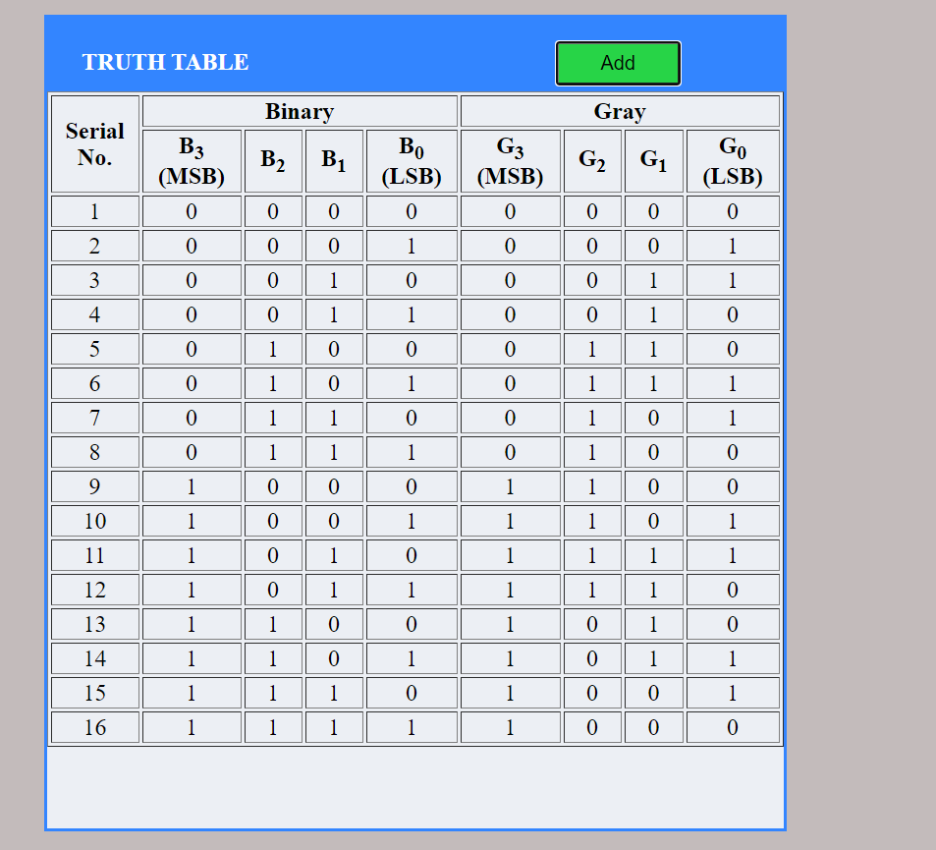

**Gray to binary conversion:**

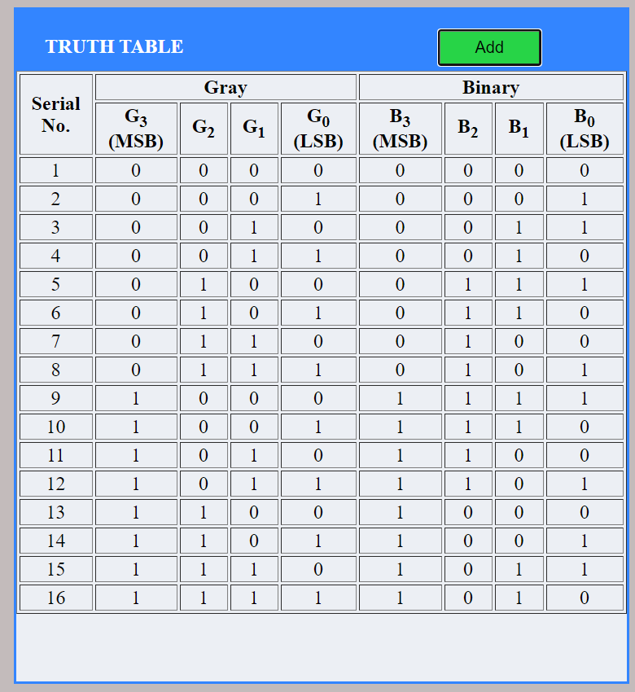

**Conclusion:**

From the above experiment we get to know about binary and gray code conversion .And also learn to analyse the truth table of binary to gray and gray to binary converter using a combination of NAND gates and to understand the working of binary to gray and gray to binary converter with the help of LEDs display.

***********

**Experiment-12**

**Aim:**

To analyse the truth table of 1-bit comparator by using NOT, AND and NOR logic gate ICs and 2-bit comparator by using 1-input NOT, 3-input AND, 2-input AND, 3-input OR and 2-input Ex-NOR logic gate ICs and to understand the working of 1-bit comparator and 2- bit comparator with the help of LEDs display.

#### **Theory:**

### **Introduction**

A magnitude digital comparator is a combinational circuit that compares two digital or binary numbers in order to find out whether one binary number is equal, less than or greater than the other binary number. We logically design a circuit for which we will have two inputs one for A and other for B and have three output terminals, one for A > B condition, one for A = B condition and one for A < B condition.

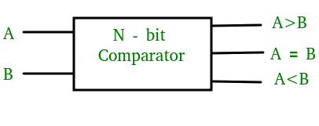

**fig:Block diagram of comparator**

**1) 1-Bit Magnitude Comparator :**

A comparator used to compare two bits is called a single bit comparator. It consists of two inputs each for two single bit numbers and three outputs to generate less than, equal to and greater than between two binary numbers. The truth table for a 1-bit comparator is given below :

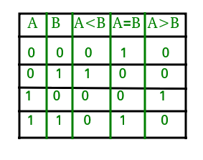

Figure: Truth Table of 1-Bit Comparator

From the above truth table logical expressions for each output can be expressed as follows:

A > B : AB'

A < B : A'B

A = B : A'B' + AB

From the above expressions we can derive the following formula:

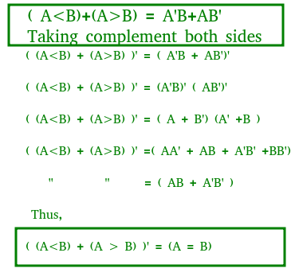

By using these Boolean expressions, we can implement a logic circuit for this comparator as given below :

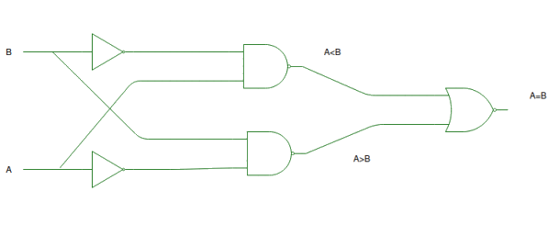

Figure: Logic Circuit of 1-Bit Comparator

**2) 2-Bit Magnitude Comparator :**

A comparator used to compare two binary numbers each of two bits is called a 2-bit magnitude comparator. It consists of four inputs and three outputs to generate less than, equal to and greater than between two binary numbers.

From the above truth table K-map for each output can be drawn as follows:

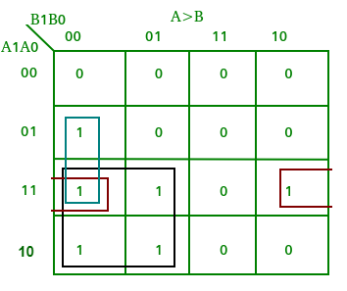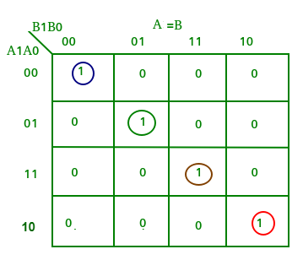

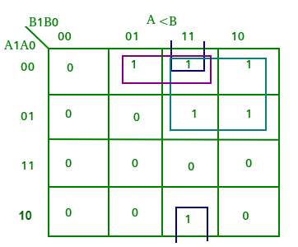

The truth table for a 2-bit comparator is given below:

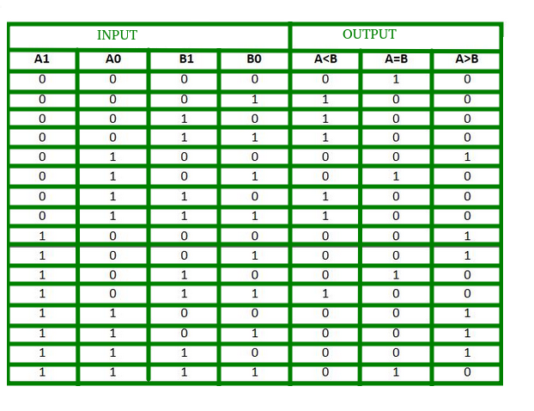

Figure-4: Truth Table of 2-Bit Comparator

From the above truth table logical expressions for each output can be expressed as follows:

A > B : A1B1’ + A0B1’B0’ + A1A0B0’

A = B : A1’A0’B1’B0’ + A1’A0B1’B0 + A1A0B1B0 + A1A0’B1B0’

: A1’B1’ (A0’B0’ + A0B0) + A1B1 (A0B0 + A0’B0’)

: (A0B0 + A0’B0’) (A1B1 + A1’B1’)

: (A0 Ex-Nor B0) (A1 Ex-Nor B1)

A < B : A1’B1 + A0’B1B0 + A1’A0’B0

By using these Boolean expressions, we can implement a logic circuit for this comparator as given below :

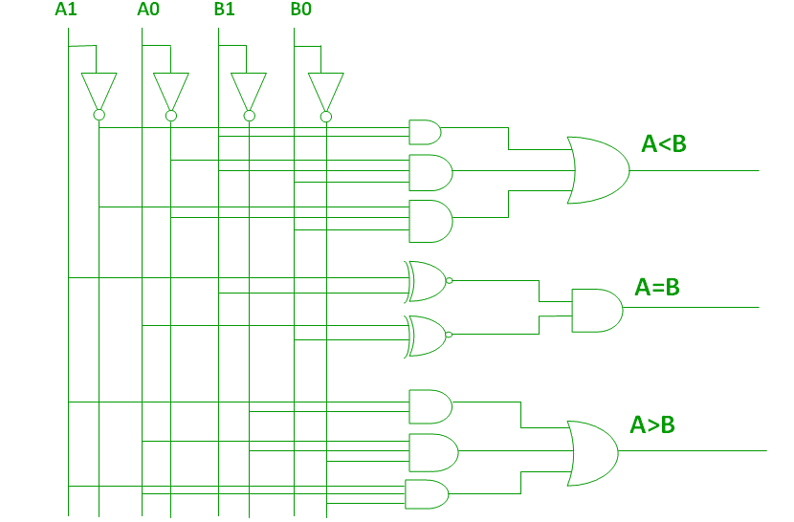

Figure-5: Logic Circuit of 2-Bit Comparator

**Procedure:**

**1-bit comparator:**

Simulator 1:

Step-1) The power supply button to supply 5V to the circuit was switched on.

Step-2)Switch 1 for input A and Switch 2 for input B was pressed.

The switch in ON state is  and the switch in OFF state is 

Step-3) i)When the input A is greater than the input B,LED 1 lits up.

ii)When the input A is lesser than the input B,LED 2 lits up.

iii)When the input A is equal to the input B,LED 3 lits up.

The LED in OFF state is  and the LED in ON state is  .

Step-4)"Add" Button to add data to the Truth Table was clicked on.

Step-5)Steps 2 to 4 for another set of data were repeated.

Step-6)"Print" to get the print out of the Truth Table was clicked on.

Simulator 2:

Step-1)The Boolean input "A" and "B" was entered.

Step-2)The Boolean output for our corresponding inputs were entered.

Step-3) "Check" Button to verify our output was clicked on.

Step-4)"Print" if you want to get print out of Truth Table was clicked.

**2- Bit Comparator**

Simulator 1:

Step-1) The power supply button to supply 5V to the circuit was switched on.

Step-2) Switch 1 for input A1,Switch 2 for input A0,Switch 3 for input B1and Switch 4 for input B0 were pressed.

The switch in ON state is  and the switch in OFF state is 

Step-3) i)When the input A1A0 is greater than the input B1B0,LED 1 lits up.

ii)When the input A1A0 is lesser than the input B1B0,LED 2 lits up.

iii)When the input XA1A0 is equal to the input B1B0,LED 3 lits up.

The LED in OFF state is  and the LED in ON state is  .

Step-4) "Add" Button to add data to the Truth Table was clicked on.

Step-5)Steps 2 to 4 for another set of data were repeated.

Step-6) "Print" to get the print out of the Truth Table was checked.

Simulator 2:

Step-1)The two bit Boolean input "A" and "B" were entered.

Step-2) Inputs should be written such that for 'A'="A1A0" and for 'B'="B1B0"

Step-3)The Boolean output for your corresponding inputs was entered.

Step-4)"Check" Button to verify your output was clicked on.

Step-5)"Print" if you want to get print out of Truth Table was clicked on.

**Output & Result:**

**1-bit comparator:**

Truth table:

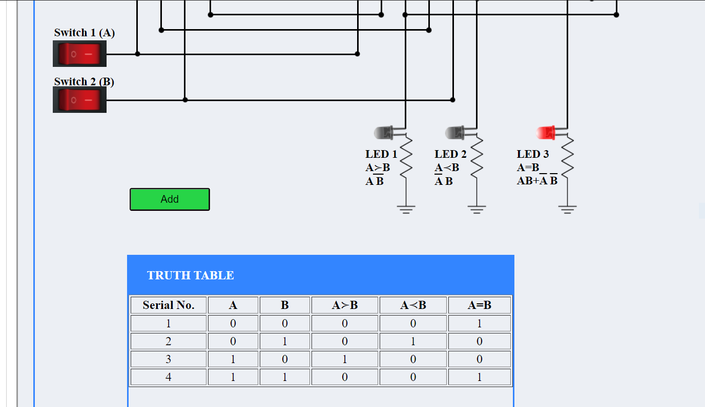

Verification table

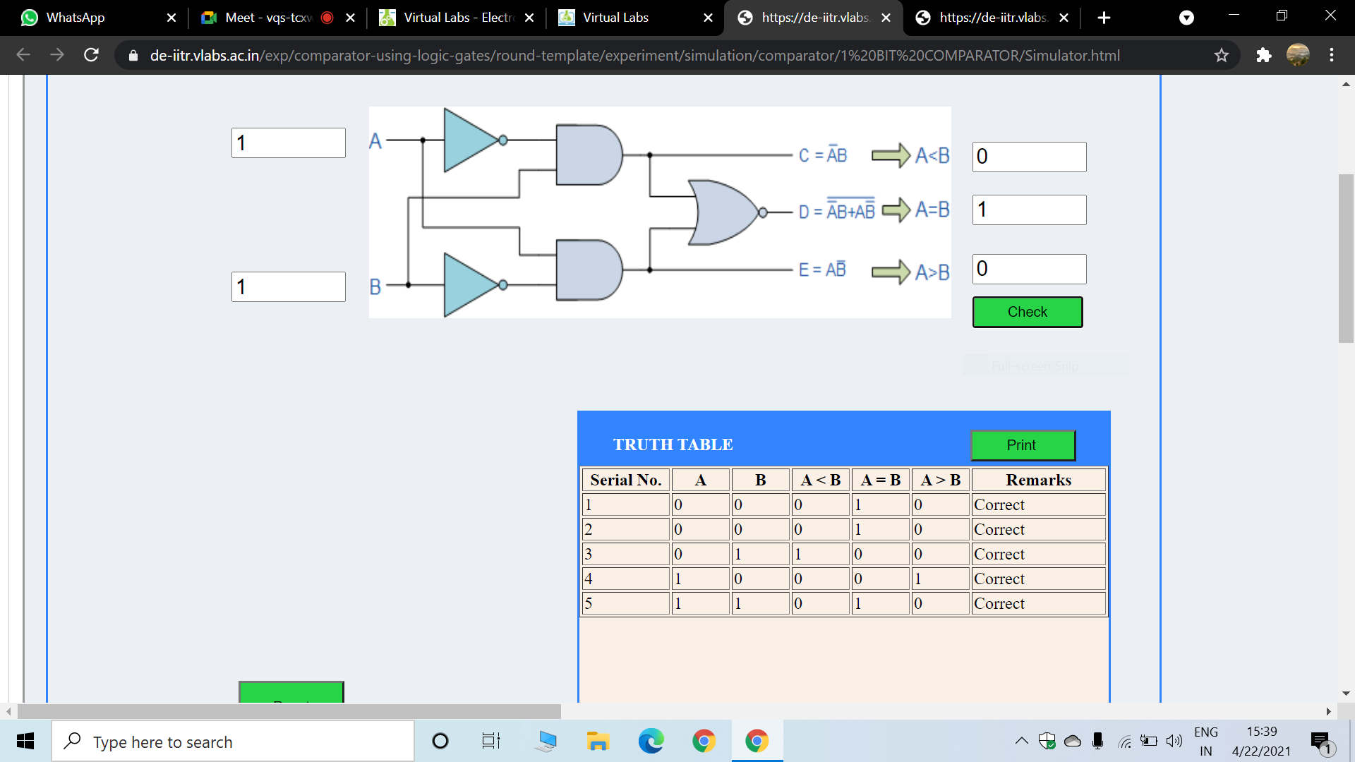

**2-Bit comparator:**

Truth Table:

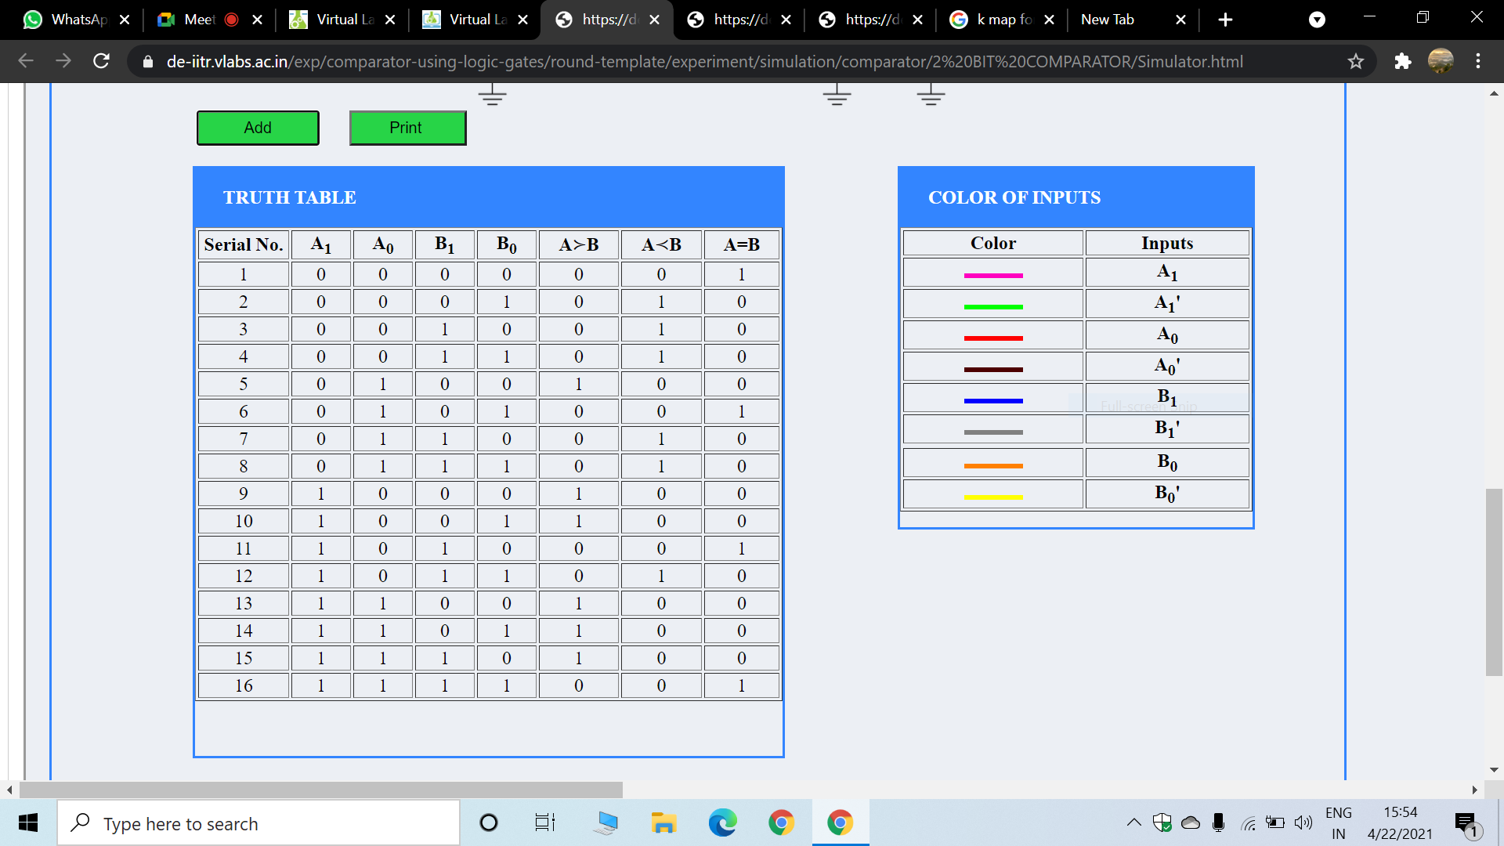

Verification table:

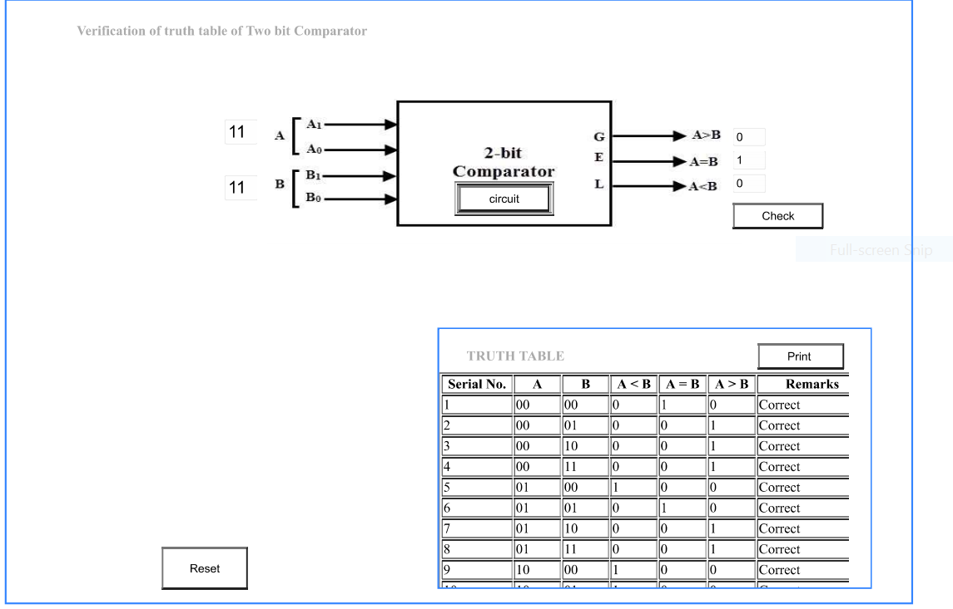

**Conclusion:**

From the above experiment we get to know about 1-bit and 2-bit comparator and also analyse the truth table of 1-bit comparator by using NOT, AND and NOR logic gate ICs and 2-bit comparator by using 1-input NOT, 3-input AND, 2-input AND, 3-input OR and 2-input Ex-NOR logic gate ICs and to understand the working of 1-bit comparator and 2- bit comparator with the help of LEDs display.

***********